Data Analysis Problem
by Marianna Pap and József Szeberényi
to accompany
The Cell: A Molecular Approach, Eighth Edition
Geoffrey M. Cooper

12.4 Analysis of Microsomes from Pigeon Pancreas

This Data Analysis Problem does not appear in the textbook.

Source: Redman, C. M., P. Siekevitz, G. E. Palade. 1966. Synthesis and transfer of amylase in pigeon pancreatic microsomes. J. Biol. Chem. 241: 1150–1158.

Corresponding chapter(s) in the textbook: Chapter 12

Review the following terms before working on the problem: cell fractionation, detergent, electron microscopy

Experiment

A postmitochondrial supernatant from pigeon pancreas cells was ultracentrifuged (100,000 × g for 1 hour), and the resulting pellet was divided into two samples. One (A) was fixed with osmium tetroxide, embedded, and sections of the sample were stained with uranyl acetate and lead citrate. The other sample (B) was resuspended in a buffer, treated with deoxycholate (a mild detergent), ultracentrifuged, and the resulting pellet was processed as A above.

Figure

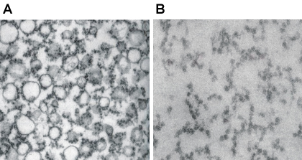
Source: Redman, C. M., P. Siekevitz, G. E. Palade. 1966. Synthesis and transfer of amylase in pigeon
pancreatic microsomes. J. Biol. Chem. 241: 1150–1158.

Questions

1. Briefly describe the important steps for preparing a postmitochondrial supernatant such as was used in this experiment.

2. What fraction was isolated in this experiment?

3. Why was deoxycholate added to sample B?

4. What type of electron microscopy was performed? What was the purpose of using uranyl acetate and lead citrate?

5. Compare the two electron micrographs.

6. Why is exocrine pancreas particularly useful for this kind of analysis?

