Data Analysis Problem
by Marianna Pap and József Szeberényi
to accompany
The Cell: A Molecular Approach, Eighth Edition
Geoffrey M. Cooper

12.2 The Release of Histamine from Mast Cells

This Data Analysis Problem is also found on page 423 of the textbook.

Source: Röhlich, P., P. Anderson, B. Uvnäs. 1971. Electron microscope observations on compound 48/80-induced degranulation in rat mast cells. J. Cell Biol. 51: 465–483.

Level of difficulty: Low

Corresponding chapter(s) in the textbook: Chapter 12

Review the following terms before dealing with the figure: histamine, secretion, formaldehyde fixation, electron microscopy, heavy metal staining

Experiment

Mast cells synthesize and store histamine in the form of membrane-bound granules. Upon stimulation of these cells, histamine is released and triggers allergic reactions in the tissues.

The figure shows the result of an experiment in which the mechanism of histamine release was studied. A suspension of mast cells was treated with a drug that induces histamine release. After 10 seconds, the cells were quickly fixed in a cold formaldehyde solution and processed for electron microscopic analysis. Sections were stained with uranyl acetate and lead citrate (scale bar, 1 μm).

Figure

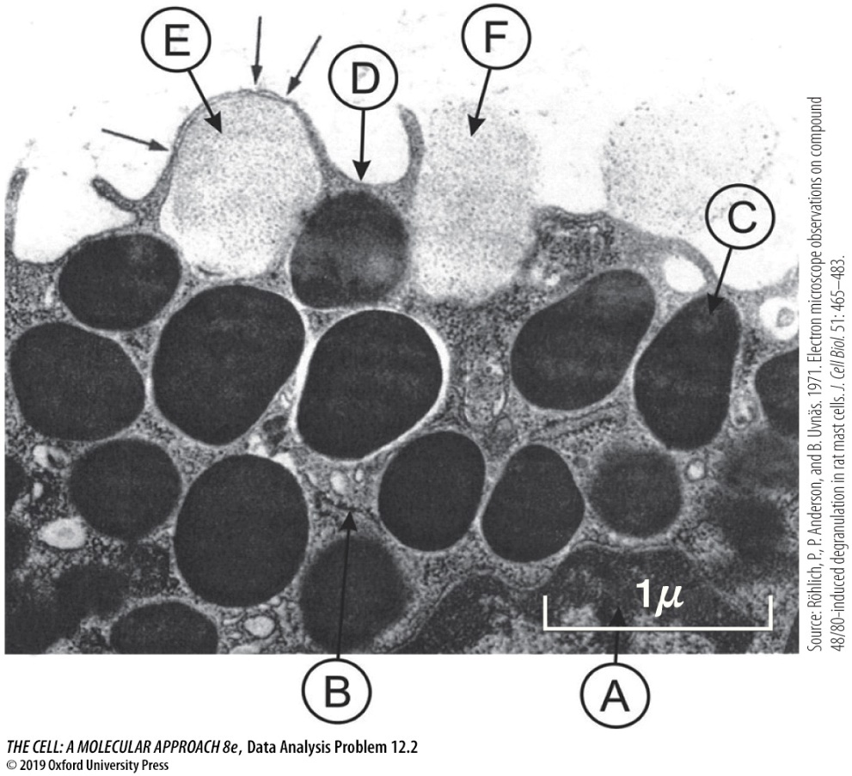

Questions

1. What are the organelles/structures labeled with capital letters?

2. What phenomenon is indicated by the arrows pointing at organelle E?

3. What is the process by which histamine is released?

