Data Analysis Problem
by Marianna Pap and József Szeberényi
to accompany
The Cell: A Molecular Approach, Eighth Edition
Geoffrey M. Cooper

12.1 The Synthesis and Posttranslational Fate of a
Bee Venom Protein

This Data Analysis Problem is also found on page 422 of the textbook.

Source: Ibrahimi, I. 1987. Signal recognition particle causes a transient arrest in the biosynthesis of prepromelittin and mediates its translocation across mammalian endoplasmic reticulum. J. Cell Biol. 104: 61–66.

Level of difficulty: High

Corresponding chapter(s) in the textbook: Chapter 12

Review the following terms before working on the problem: secretion, protein synthesis, posttranslational protein processing, in vitro translation, mRNA, [³H]proline/[³⁵S]methionine labeling, microsomal fraction, endoplasmic reticulum, signal recognition particle (SRP), SRP receptor, proteases, SDS-polyacrylamide gel electrophoresis, autoradiography

Experiment

Promelittin (PM) is a small secretory protein, a predominant component of queen bee venom. Its synthesis and posttranslational metabolism was studied in an in vitro translation system containing total bee venom gland mRNA, [³H]proline, [³⁵S]methionine, and other molecules required for protein synthesis. Supplements were added to this system as follows:

Sample 1: Rough ER vesicles (rough microsomes, RM)
Sample 2: No additional components
Sample 3: Cycloheximide (a protein synthesis inhibitor) was added at the end of translation, followed by the addition of rough ER vesicles (RM) and another 30 minute incubation.
Sample 4: Rough ER vesicles (RM-E) treated with N-ethylmaleimide (an inhibitor of SRP receptor) were added at the beginning of translation.
Sample 5: Same as sample 4, except this sample was digested with proteinase K after translation

The samples were subjected to SDS polyacrylamide gel electrophoresis followed by autoradiography.

Figure

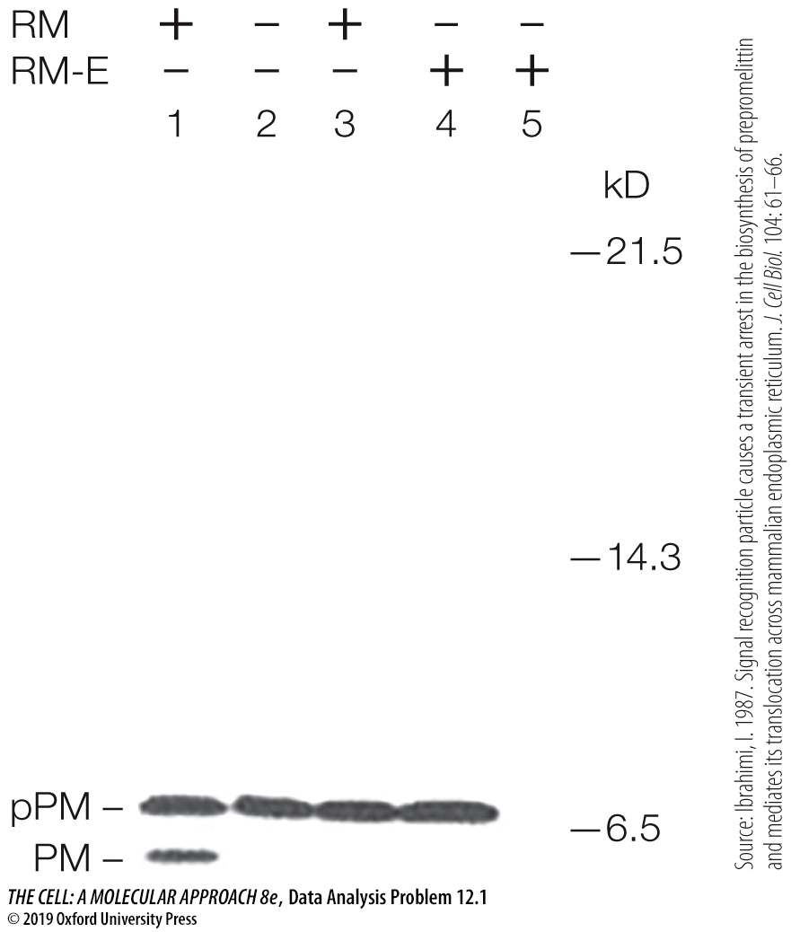

Questions

1. Explain how the bands pPM and PM were resolved and suggest a possible relationship between them.

2. What conclusion can be drawn from comparing samples 1 and 2?

3. What conclusion can be drawn from comparing samples 1 and 3?

4. What conclusion can be drawn from comparing samples 1 and 4?

5. What conclusion can be drawn from comparing samples 4 and 5?

