Data Analysis Problem
by Marianna Pap and József Szeberényi
to accompany
The Cell: A Molecular Approach, Eighth Edition
Geoffrey M. Cooper

11.3 In situ Hybridization with Radioactive rRNA

This Data Analysis Problem does not appear in the textbook.

Source: Gall, J. G., M. L. Pardue. 1969. Formation and detection of RNA-DNA molecules in cytological preparations. Proc. Natl. Acad. Sci. 63: 378–383.

Chapter(s) in the textbook: Chapter 11 (and 1, 4 and 8)

Review the following terms before working on the problem: Xenopus laevis, molecular hybridization, radioactive labeling, rRNA, autoradiography, silver grains

Experiment

A section of the ovary of the frog Xenopus laevis was hybridized in situ with radioactively labeled rRNA and analyzed by autoradiography.

Figure

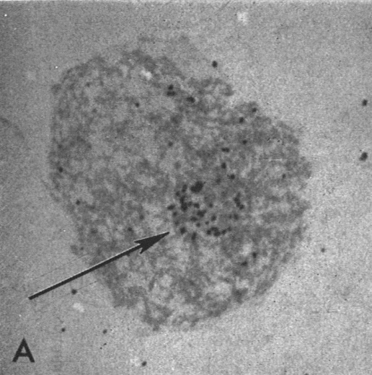
Source: Gall, J. G., M. L. Pardue. 1969. Formation and detection of RNA-DNA molecules in cytological preparations. Proc. Natl. Acad. Sci. 63: 378–383.

Questions

1. What organelle is shown in this micrograph?

2. What region in the organelle is indicated by the arrow?

3. What conclusion can be drawn from the distribution of silver grains?

