Data Analysis Problem
by Marianna Pap and József Szeberényi
to accompany
The Cell: A Molecular Approach, Eighth Edition
Geoffrey M. Cooper

11.1 Nuclear Import of a Protein

This Data Analysis Problem is also found on pages 380–381 of the textbook.

Source: Görlich, D., S. Prehn, R. A. Laskey, E. Hartmann. 1994. Isolation of a protein that is essential for the first step of nuclear protein import. Cell 79: 767–778.

Level of difficulty: Medium

Corresponding chapter(s) in the textbook: Chapter 11

Review the following terms before working on the problem: Ran protein, importin, cell membrane, nuclear membrane, fluorescent labeling, nuclear localization signal, fluorescence microscopy, cytosol, ATP

Experiment

This experiment studied the role of two proteins, Ran and importin, in nuclear protein transport. Permeabilized tissue culture cells were used: Their plasma membrane is permeable to proteins, but their nuclear membrane retains the ability for selective protein transport. The cells were incubated with fluorescently labeled protein molecules, containing a nuclear localization signal. Cytosol, Ran, importin, and ATP were present or absent, as indicated in the figure. Cells exposed to these different conditions were then analyzed by fluorescence microscopy.

Figure

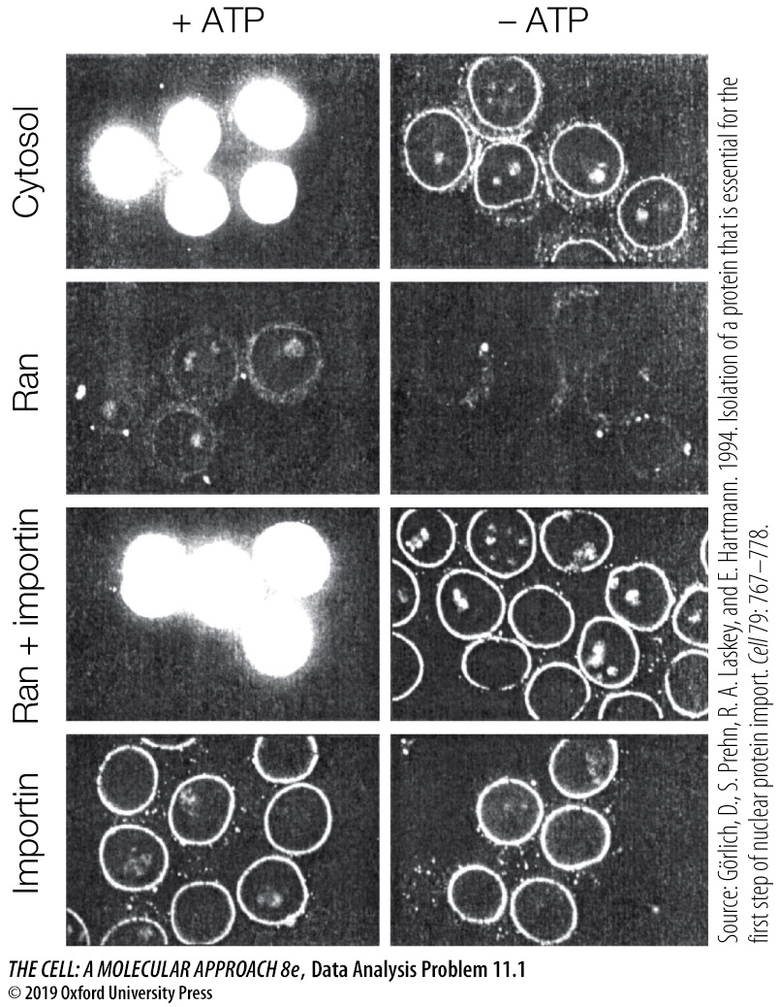

Questions

1. What actions does Ran perform by itself?

2. What actions does importin perform by itself?

3. How do Ran and importin perform together in the nuclear import of protein?

4. Why is ATP required?

5. What conclusion can be drawn regarding the cytosol sample?

