Data Analysis Problem
by Marianna Pap and József Szeberényi
to accompany
The Cell: A Molecular Approach, Eighth Edition
Geoffrey M. Cooper

10.1 Protein Synthesis in Poliovirus-Infected Cells

This Data Analysis Problem is also found on page 349 of the textbook.

Source: Gradi, A., Y. V. Svitkin, H. Imataka, N. Sonenberg. 1998. Proteolysis of human eukaryotic translation initiation factor eIF4GII, but not eIF4GI, coincides with the shutoff of host protein synthesis after poliovirus infection. Proc. Natl. Acad. Sci. USA 95: 11089–11094.

Level of difficulty: Medium

Corresponding chapter(s) in the textbook: Chapter 10

Review the following terms before working on the problem: HeLa cells, poliovirus, mock infection, [³⁵S]methionine labeling, cytoplasmic protein extracts, SDS polyacrylamide gel electrophoresis (SDS-PAGE), autoradiography

Experiment

HeLa human tumor cell cultures were mock-infected (samples 1–3) or infected with poliovirus for the time periods indicated in the figure (samples 4–10). The cells were labeled with [³⁵S]methionine for 30 minutes at the end of the incubation periods, and equal amounts of cytoplasmic protein extracts were separated by SDS-polyacrylamide gel electrophoresis. The gel was dried, and autoradiography was performed. (The charges of electrodes during electrophoresis are indicated by and .)

Figure

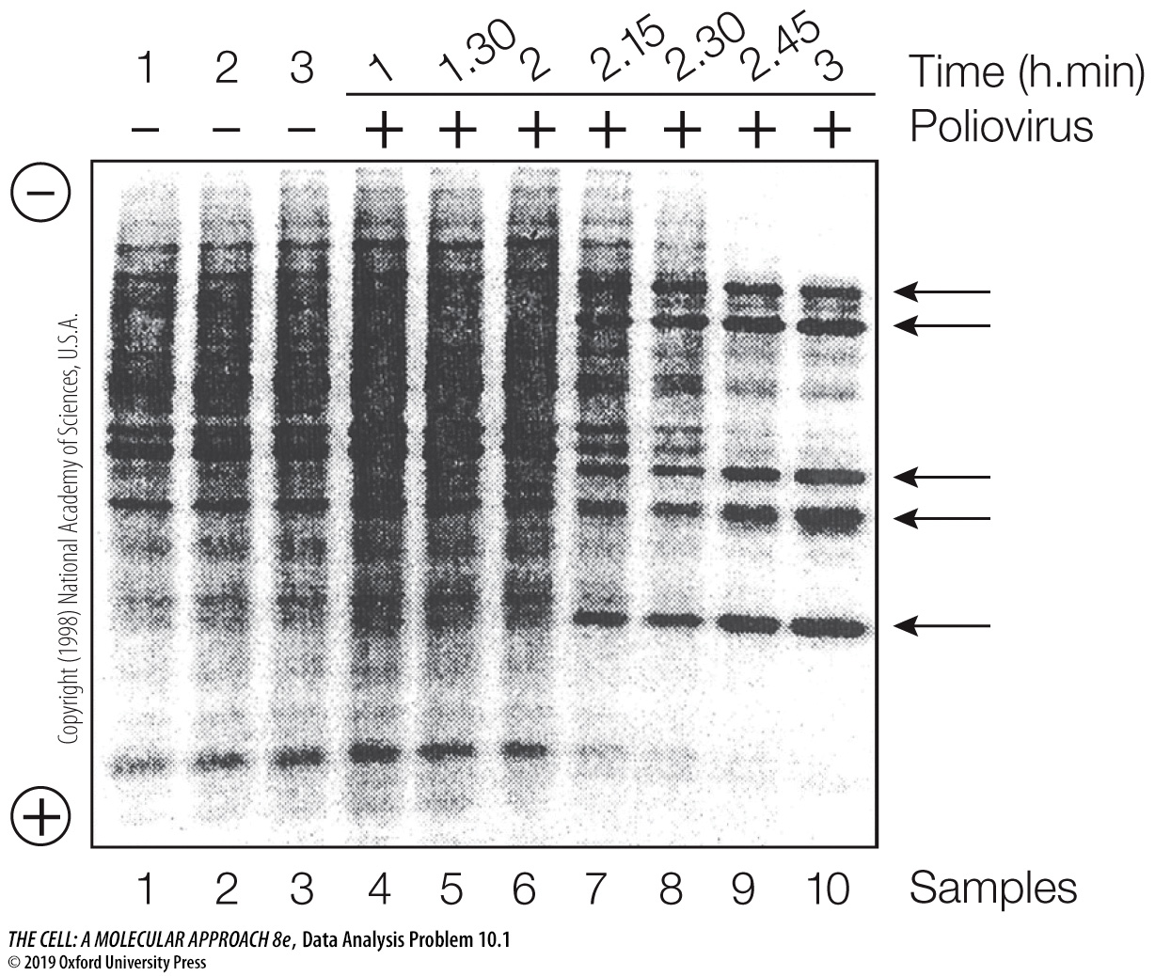
Copyright (1998) National Academy of Sciences, U.S.A.

Questions

1. What was the purpose of [³⁵S]methionine labeling?

2. Explain the band patterns made by the mock-infected samples (samples 1–3)?

3. What was the initial effect of poliovirus infection on [³⁵S]methionine incorporation (compare samples 1 and 4)?

4. What are the bands indicated by the arrows on the right side of the autoradiograph?

5. What is the effect of longer poliovirus exposure on [³⁵S]methionine incorporation (compare samples 3 and 10)?

6. What conclusions can be drawn from the results of this experiment?

