Data Analysis Problem
by Marianna Pap and József Szeberényi
to accompany
The Cell: A Molecular Approach, Eighth Edition
Geoffrey M. Cooper

8.4 Pulse-Chase Labeling of Newly Synthesized RNA in
E. coli Cells

This Data Analysis Problem does not appear in the textbook.

Source: Nierlich, D. P., G. J. Murakawa. 1996. The decay of bacterial messenger RNA. Progress in Nucleic Acid Research and Molecular Biology 52: 153–216.

Corresponding chapter(s) in the textbook: Chapter 8

Review the following terms before working on the problem: pulse-chase labeling, [³H]Uridine, velocity centrifugation in a density gradient, ribosomes, ribosomal subunits, rRNA, mRNA, tRNA, ultraviolet absorption (A₂₆₀)

Experiment

E. coli cells were incubated for 45 seconds with [³H]uridine, and then an excess of unlabeled uridine was added to the culture. Samples were withdrawn after 2 (A), 6 (B), and 20 minutes (C). The cells were disrupted, and the extracts were fractionated in sucrose gradients under conditions that cause the dissociation of ribosomes. Fractions were collected from the sucrose gradients, and ultraviolet absorption at 260 nm (optical density OD₂₆₀; blue ○─○) and ³H-radioactivity (³H cpm [counts per minute]; red ●─●) were measured in each fraction.

Figure

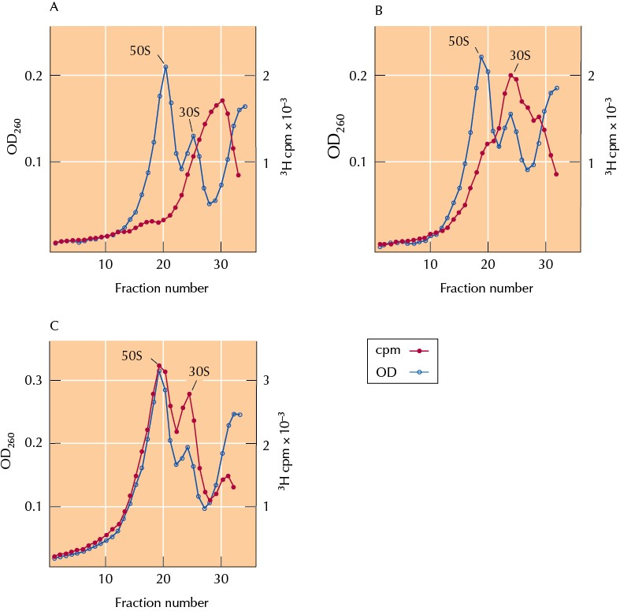

Questions

1. Why was pulse-chase labeling used in this experiment?

2. How did the sucrose density gradient centrifugation procedure separate the samples?

3. How would you dissociate ribosomes into subunits? (Ribosomal subunits are held together by Mg²⁺ ions.)

4. Based on the molecules present in all the fractions of graph A, describe the radioactive molecules present in fraction 30.

5. Why are so few 50S ribosomal subunits labeled after 45 seconds of [³H]uridine incubation and 2 minutes of chase (graph A)?

6. Why are 30S ribosomal subunits being labeled faster than 50S subunits (compare graphs B and C)?

7. Explain the almost complete disappearance of the radioactivity peak in fraction 30 after 20 minutes of chase (compare graphs A and C).

8. Explain why the labeling of ribosomal subunits is still strong even after 20 minutes of chase (graph C).

9. What conclusions can be drawn from the results of this experiment?

