Data Analysis Problem
by Marianna Pap and József Szeberényi
to accompany
The Cell: A Molecular Approach, Eighth Edition
Geoffrey M. Cooper

8.2 Ribosomal RNA Metabolism

This Data Analysis Problem is also found on page 283 of the textbook.

Source: Warner J. R., R. Soeiro, H. C. Birnboim, Girard M., J. E. Darnell. 1966. Rapidly labeled HeLa cell nuclear RNA. I. Identification by zone sedimentation of a heterogeneous fraction separate from ribosomal precursor RNA. Journal of Molecular Biology 19: 349–61.

Level of difficulty: Medium

Corresponding chapter(s) in the textbook: Chapters 8 and 10

Review the following terms before working on the problem: [³H]uridine labeling, nucleoli, ribosomal RNAs, velocity centrifugation, radioactivity and UV absorption measurements

Experiment

Three cultures of HeLa cells were labeled with [³H]uridine for 25 minutes and then subjected to the following treatments:

A. Control cells: no treatment
B. Incubation with actinomycin D (which inhibits RNA synthesis) for an additional 10 minutes
C. Incubation with actinomycin D for an additional 35 minutes

After incubation with actinomycin D, nucleolar RNA was isolated from the three cultures. The RNA samples were fractionated by high-speed centrifugation in a sucrose gradient, and fractions of equal volume were collected from the bottom of the tube. (The first and last fractions thus correspond to the bottom and the top of the gradients, respectively.) Radioactivity and ultraviolet absorption (A₂₆₀) of the fractions were measured.

Figures

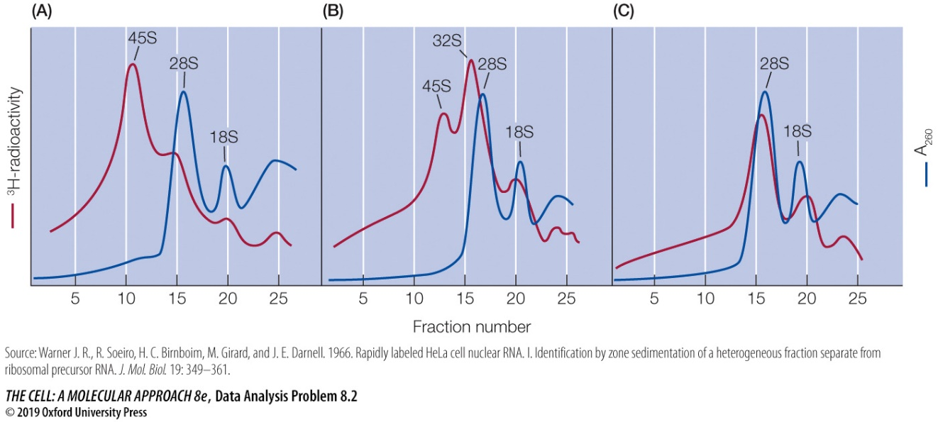

Questions

1. Why is [³H]uridine suitable for labeling newly synthesized RNA molecules?

2. What is the purpose of treating cells with actinomycin D in this experiment?

3. Why are the radioactivity and UV absorption curves so different in graph A?

4. What is the relationship between 45S, 28S, and 18S RNA species? Suggest an explanation for the presence of 32S RNA in graph B.

5. Account for the strong similarity between the UV absorption curves of the three figures.

