Data Analysis Problem
by Marianna Pap and József Szeberényi
to accompany
The Cell: A Molecular Approach, Eighth Edition
Geoffrey M. Cooper

8.1 In vivo Labeling of Nucleic Acids

This Data Analysis Problem is also found on pages 282–283 of the textbook.

Source: Davidson, J. N. 1965. The Biochemistry of the Nucleic Acids. Methnen & Co. Ltd., London, Fifth edition, Fig. 8.5.

Level of difficulty: Low

Corresponding chapter(s) in the textbook: Chapter 8 (and 2, 7, and 17)

Review the following terms before working on the problem: radioisotopes, radioactive labeling, cell fractionation, isolation of DNA and RNA

Experiment

Rabbits were injected with [³²P]phosphate intraperitoneally and sacrificed after 2, 5, 8, 12, 18, 24, 48, or 168 hours of radioisotope administration. DNA, nuclear RNA (nRNA), and cytoplasmic RNA (cRNA) were prepared from the kidneys, and their specific activities (radioactivity/mg of nucleic acid) were determined.

Figure

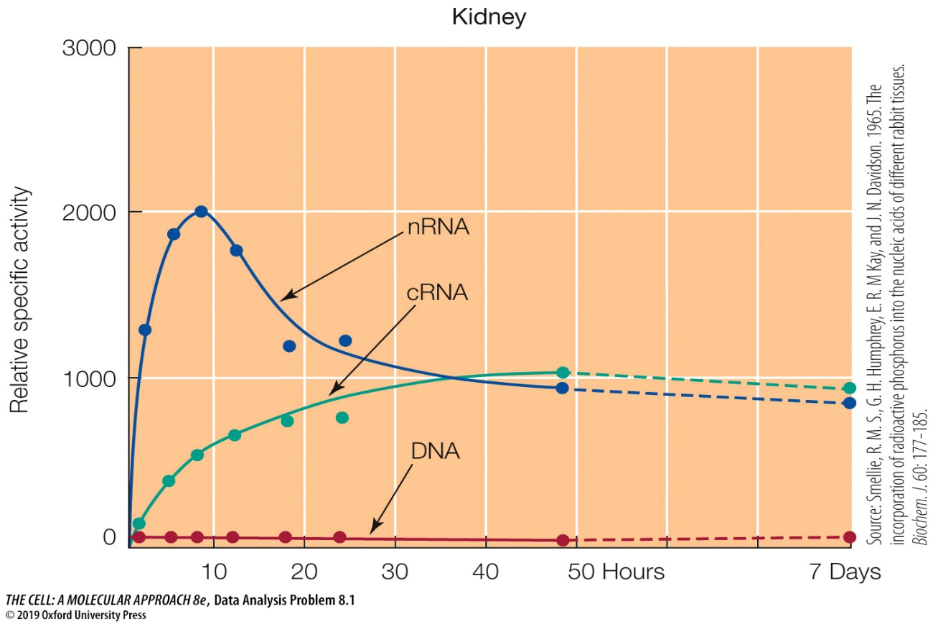

Questions

1. What processes were studied in this experiment?

2. What can you conclude about the division of kidney cells during the time of labeling?

3. What conclusions can be drawn from the nuclear (nRNA) and cytoplasmic RNA (cRNA) curves?

4. Why didn’t the specific activities of nRNAs and cRNAs decrease significantly after 2 days of labeling?

