Data Analysis Problem
by Marianna Pap and József Szeberényi
to accompany
The Cell: A Molecular Approach, Eighth Edition
Geoffrey M. Cooper

7.3 Replication of SV40 DNA

This Data Analysis Problem does not appear in the textbook.

Source: Fareed, G. C., C. F. Garon, N. P. Salzman. 1972. Origin and direction of simian virus 40 deoxyribonucleic acid replication. J. Virol. 10: 484–491.

Corresponding chapter(s) in the textbook: Chapter 7 (and 20)

Review the following terms before working on the problem: SV40 virus, DNA replication, EcoRI restriction endonuclease, replication bubble, origin of replication, electron microscopy, permissive cells

Experiment

Viral DNA was isolated from SV40-infected monkey cells 29 hours postinfection, digested with EcoRI restriction endonuclease, and studied using electron microscopy. The circular SV40 DNA molecule contains a single EcoRI cleavage site. The electron micrographs illustrate 10 different DNA molecules.

Figure

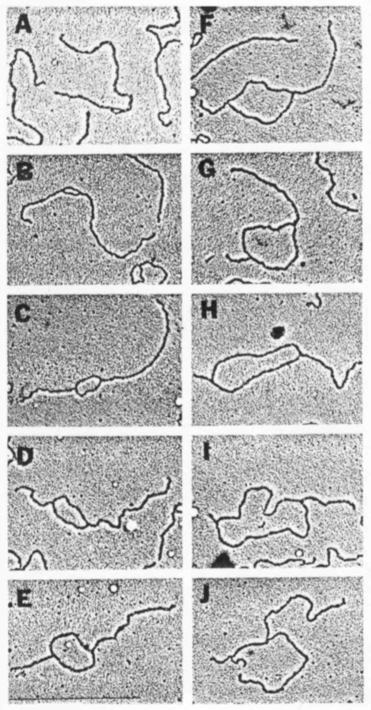
Source: Fareed, G. C., C. F. Garon, N. P. Salzman. 1972. Origin and
direction of simian virus 40 deoxyribonucleic acid replication. J. Virol. 10: 484–491.

Questions

1. What technique was used to visualize the DNA molecules?

2. What was the significance of monkey cells being permissive to SV40 virus in this experiment?

3. Compare the size of the replication bubble in each micrograph in order from A to J. What can you conclude from your observations?

4. Compare the position of the replication bubble in each micrograph. What can you conclude from your observations?

