Data Analysis Problem
by Marianna Pap and József Szeberényi
to accompany
The Cell: A Molecular Approach, Eighth Edition
Geoffrey M. Cooper

7.2 The Activity of Telomerase

This Data Analysis Problem is also found on page 251 of the textbook.

Source: Kim, N. W., M. A. Piatyszek, K. R. Prowse, C. B. Harley, M. D. West, P. L. Ho, G. M. Coviello, W. E. Wright, S. L. Weinrich, J. W. Shay. 1994. Specific association of human telomerase activity with immortal cells and cancer. Science 266: 2011–2015.

Level of difficulty: High

Corresponding chapter(s) in the textbook: Chapter 7

Review the following terms before working on the problem: telomeric repeats, telomerase, immortal cells, oligonucleotide, polymerase chain reaction (PCR), RNase, phenol extraction, protease, polyacrylamide gel electrophoresis, autoradiography

Experiment

The experiment shows the results of an assay for telomerase in which extracts of immortal cells (I; samples 1, 3–7), normal fibroblasts (F; sample 8), and purified telomerase (T; sample 9) were incubated in a reaction mixture with a synthetic, 18-nucleotide-long telomerase substrate. Lane 1 is the no-substrate control; lane 2 is the no-extract control; lane 3 is the reaction with untreated extract; lanes 4, 5, 6, and 7 are extracts that were pretreated with boiling, RNase, phenol extraction, or protease, respectively. Under the experimental conditions, telomerase added telomeric repeats (GGTTAG) to the 3′-end of the substrate. The products of the telomerase reaction were then amplified by PCR in the presence of [α-³²P]-labeled dNTPs. The radiolabeled products were separated by electrophoresis, and the figure shows the autoradiograph of the gel. Molecular sizes (in base pairs) are shown on the left.

Figure

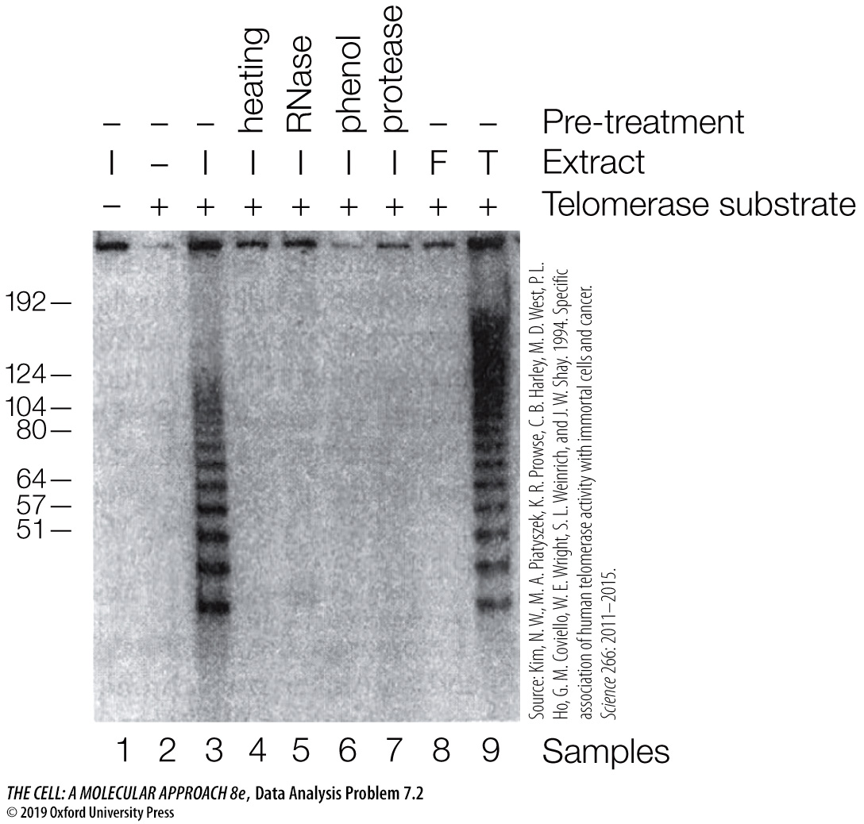

Questions

1. What can be concluded from comparing samples 3 and 9?

2. What can be concluded from comparing samples 1, 2, and 3?

3. What is the difference between the immortal cell line and normal fibroblasts (compare samples 3 and 8)?

4. How does RNase treatment of the cell extract (compare samples 3 and 5) affect the telomerase reaction? What do you conclude from this observation?

5. What was the effect of heating, phenol extraction, and protease treatment of the cell extracts (samples 3, 4, 6, and 7)? What conclusion can be drawn from these results?

