Data Analysis Problem
by Marianna Pap and József Szeberényi
to accompany
The Cell: A Molecular Approach, Eighth Edition
Geoffrey M. Cooper

6.1 Nuclease Digestion of Chromatin

This Data Analysis Problem is also found on page 213 of the textbook.

Source: Roufa, D. J., M. A. Marchionni. 1982. Nucleosome segregation at a defined mammalian chromosomal site. Proc. Natl. Acad. Sci. 79: 1810–1814.

Level of difficulty: Medium

Corresponding chapter(s) in the textbook: Chapter 6

Review the following terms before working on the problem: nuclear fraction, nucleases, chromatin, gel electrophoresis

Experiment

A nuclear fraction from Chinese hamster cells was digested with Staphylococcus nuclease. At the time points indicated, samples were withdrawn from the reaction mixture and DNA was extracted and subjected to gel electrophoresis. and indicate the position of each electrode during electrophoresis. The gel was stained with ethidium bromide and photographed.

Figure

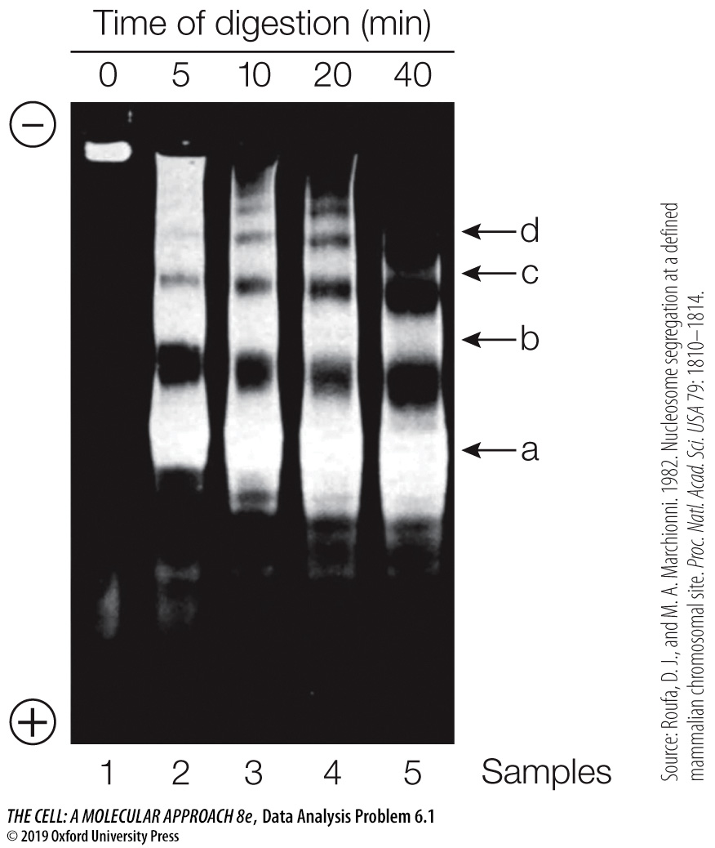

Questions

1. Why does the undigested sample (sample 1) appears as it does?

2. Explain the ladder-like band patterns in samples 2 to 5.

3. What kind of DNA molecules are present in bands a, b, c, and d?

4. Why did the bands migrate closer to the cathode as the length of digestion increased?

5. What would be revealed in a gel if the length of this digestion was significantly
increased?

6. What does this experiment tell us about the structure of chromatin?

