Data Analysis Problem
by Marianna Pap and József Szeberényi
to accompany
The Cell: A Molecular Approach, Eighth Edition
Geoffrey M. Cooper

5.3 Two-Dimensional Fractionation of Proteins Synthesized in a Virus-Infected Cell

This Data Analysis Problem does not appear in the textbook.

Source: Khandjan, E. W., J.-M. Matter, N. Léonard, R. Weil. 1980. Simian virus 40 and polyoma virus stimulate overall cellular RNA and protein synthesis. Proc. Natl. Acad. Sci. USA 77: 1476–1480.

Corresponding chapter(s) in the textbook: Chapter 5 (and 10 and 20)

Review the following terms before working on the problem: cell cultures, SV40 virus, [³⁵S]methionine labeling, differential centrifugation, two-dimensional electrophoresis, SDS polyacrylamide gel electrophoresis, isoelectric focusing, autoradiography

Experiment

Monkey kidney cells were mock-infected (A) or infected with SV40 virus (B) for 46 hours. The cultures were labeled with [³⁵S]methionine for the last hour of infection. Nuclear fractions were prepared, and proteins were extracted from them. Equal amounts of protein were subjected to two-dimensional polyacrylamide gel electrophoresis (1st dimension, horizontal: isoelectric focusing; 2nd dimension, vertical: SDS-polyacrylamide gel electrophoresis). The gels were dried and exposed to an X-ray film. The figure shows the autoradiographs.

Figure

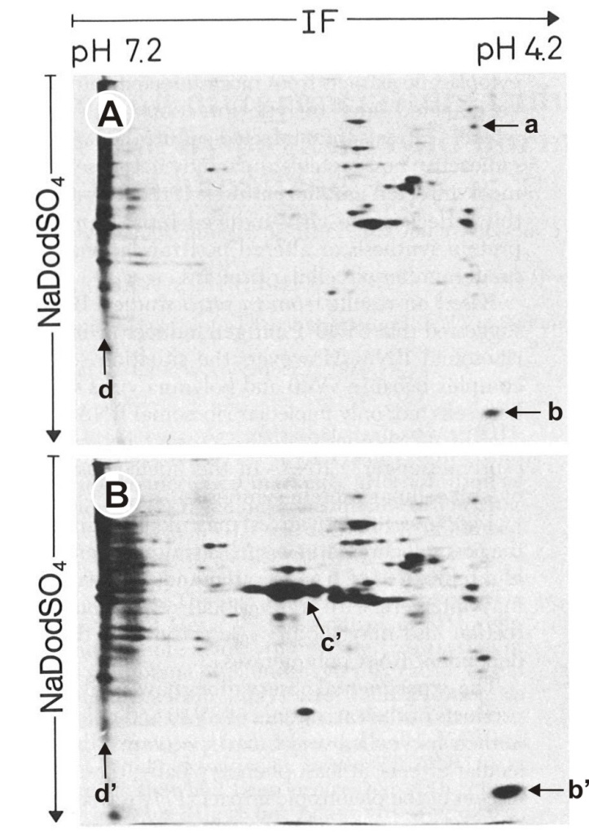
Source: Khandjan, E. W., J.-M. Matter, N. Léonard, R. Weil. 1980. Simian virus 40 and polyoma virus stimulate overall cellular RNA and protein synthesis. Proc. Natl. Acad. Sci. USA 77: 1476–1480.

Questions

1. What was the purpose of the [³⁵S]methionine labeling?

2. What happened to the protein in spot a in the virus-infected cells?

3. What happened to the protein in spot b/b′ in the virus-infected cells?

4. What kind of protein is spot c′?

5. Why did the proteins in spots b′ and c′ migrate differently?

6. Why did the proteins in the long d/d′ spots not move during isoelectric focusing?

