Data Analysis Problem
by Marianna Pap and József Szeberényi
to accompany
The Cell: A Molecular Approach, Eighth Edition
Geoffrey M. Cooper

5.1 Microarray Analysis of Gene Expression in Retina Cells

This Data Analysis Problem is also found on page 183 of the textbook.

Source: LaRue, A., S. S-M. Zhang, C. Barustable. 2002. Generating microarrays for retinal studies using a high-throughput DNA isolation system. Focus (Invitrogen) 24: 14–15.

Level of difficulty: High

Corresponding chapter(s) in the textbook: Chapter 5 (and 4 and 7)

Review the following terms before working on the problem: DNA microarray, cDNA synthesis, cDNA library, recombinant plasmid, polymerase chain reaction (PCR), molecular hybridization, probe, fluorescent labeling, fluorescence microscopy, gene expression

Experiment

A microarray was hybridized with a mixture of two differentially labeled fluorescent cDNAs, one prepared using retinal RNA of 1-day-old mice (labeled with a green fluorescent dye) and the other prepared using retinal RNA of 28-day-old mice (red fluorescence). The two probes were prepared from identical amounts of retinal tissues and were mixed together for hybridization to the microarray. Unhybridized probes were washed away, and the microarray was photographed in a fluorescence microscope.

Figure

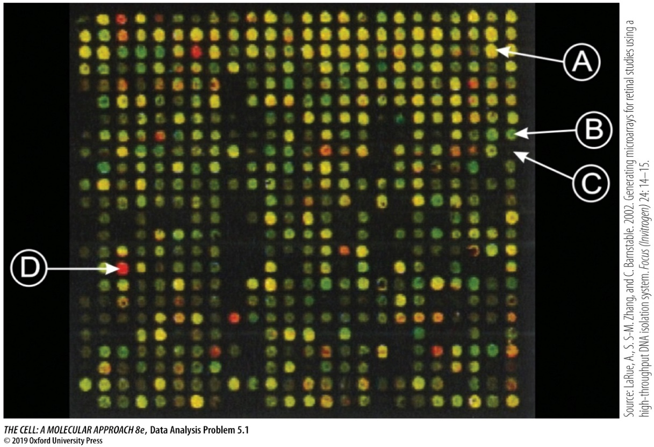

Questions

1. How can relative levels of expression in the retinas of 1-day-old and 28-day-old mice be determined in this experiment?

2. What conclusions can be drawn from observations of spots A, B, C, and D?

