Data Analysis Problem
by Marianna Pap and József Szeberényi
to accompany
The Cell: A Molecular Approach, Eighth Edition
Geoffrey M. Cooper

4.5 Analysis of a Clone of a Human cDNA Library Coding for a Lysosomal Enzyme

This Data Analysis Problem does not appear in the textbook.

Source: Pohlmann, R., C. Krentler, B. Schmidt, W. Schröder, G. Lorkowski, J. Culley, G. Mersmann, C. Geier, A. Waheed, S. Gottschalk, K.-H. Grzeschik, A. Hasilik, K. von Figura. 1988. Human lysosomal acid phosphatase: cloning, expression and chromosomal assignment. EMBO J. 7: 2343–2350.

Corresponding chapter(s) in the textbook: Chapter 4

Review the following terms before working on the problem: hepatoma, cDNA library, λ phage, expression vector, N- and C-terminus, lysosomes, acid phosphatase, SDS polyacrylamide gel electrophoresis (SDS-PAGE), Coomassie blue staining, Western blot analysis

Experiment

A human hepatoma cDNA library was constructed in a λ bacteriophage expression vector. The vector contains the lacZ gene from the E. coli lactose operon that codes for the β-galactosidase enzyme. cDNAs of the library are ligated into the distal end of lacZ. The fusion genes are transcribed into fusion mRNAs consisting of lac Z sequences and cDNA sequences in their 5′-end and 3′-end regions, respectively. cDNAs in this vector are thus expressed as fusion proteins: the N-terminus is the β-galactosidase enzyme, while the C-terminus is coded by the cDNA inserted into the vector as shown in Figure A. E.coli cell cultures were infected with the empty vector (samples 1 and 3; see Figure B) or with a recombinant λ phage containing the cDNA of a human lysosomal acid phosphatase (samples 2 and 4). Cell extracts were prepared, subjected to SDS-PAGE, and the gels were either stained with Coomassie blue (samples 1 and 2) or subjected to Western blot analysis using an anti-phosphatase antibody (samples 3 and 4). (M, marker proteins of known molecular mass.)

Figures

(A)

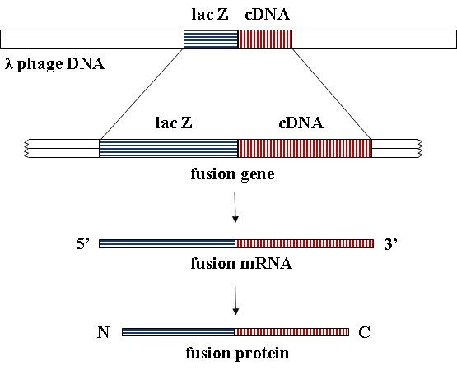

(B)

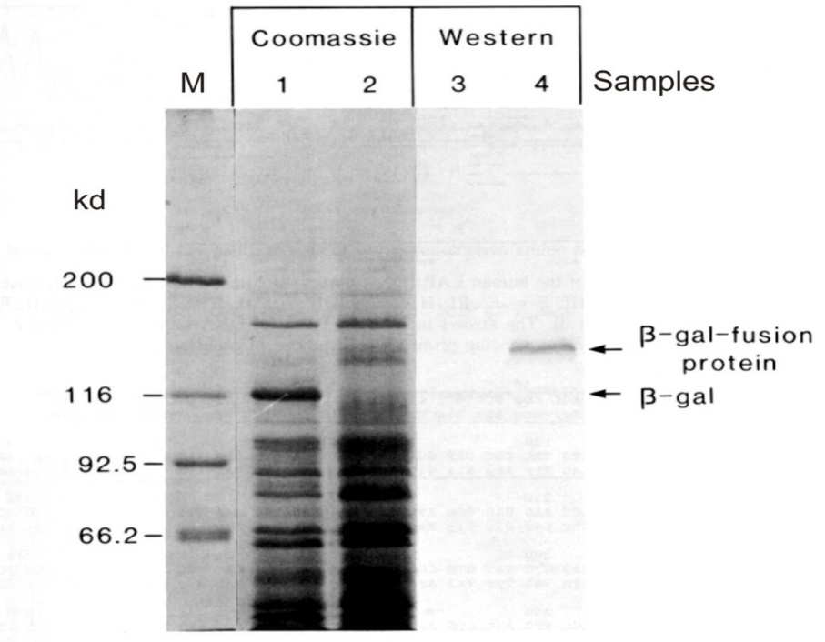
Source: Pohlmann, R., C. Krentler, B. Schmidt, W. Schröder, G. Lorkowski, J. Culley, G. Mersmann, C. Geier, A. Waheed, S. Gottschalk, K.-H. Grzeschik, A. Hasilik, K. von Figura. 1988. Human lysosomal acid phosphatase: cloning, expression and chromosomal assignment. EMBO J. 7: 2343–2350.

Questions

1. Is the β-gal enzyme that is expressed in the control cells (samples 1 and 3) from the phage DNA, from the E. coli genome, or both?

2. Is the coding region of acid phosphatase in frame with the β-gal gene in the vector?

3. What would the Western blot look like if anti-β-gal antibody had been used?

