**Data Analysis Problem**

by Marianna Pap and József Szeberényi

to accompany

*The Cell: A Molecular Approach,* Eighth Edition

Geoffrey M. Cooper

**4.1 Agarose Gel Electrophoresis of Polyethylene Glycol Treated DNA Samples**

This Data Analysis Problem is also found on page 154 of the textbook.

**Source:** Hartley, J. L., H. Bowen, 1993. PEG precipitation for selective removal of small DNA fragments. *Focus* (*Life Technologies*) 18: 27.

**Level of difficulty:** Medium

**Corresponding chapter(s) in the textbook:** Chapter 4

**Review the following terms before working on the problem:** DNA, agarose gel, electrophoresis, centrifugation

**Experiment**

A 50 base pair (bp) DNA ladder solution (containing DNA fragments of several lengths differing by 50 bp) was divided into 7 samples. One was left untreated (sample 1). The others were treated with polyethylene glycol (PEG) at the following final concentrations: 10% (sample 2), 8.3% (sample 3), 6.7% (sample 4), 5% (sample 5), 3.3% (sample 6) and 1.7% (sample 7). Samples 2 to 7 were centrifuged, the pellets were dissolved in a gel loading buffer, and all seven samples were electrophoresed in an agarose gel. The positions of the electrodes ( and ) during electrophoresis and the loading wells (→) are indicated.

**Figure**

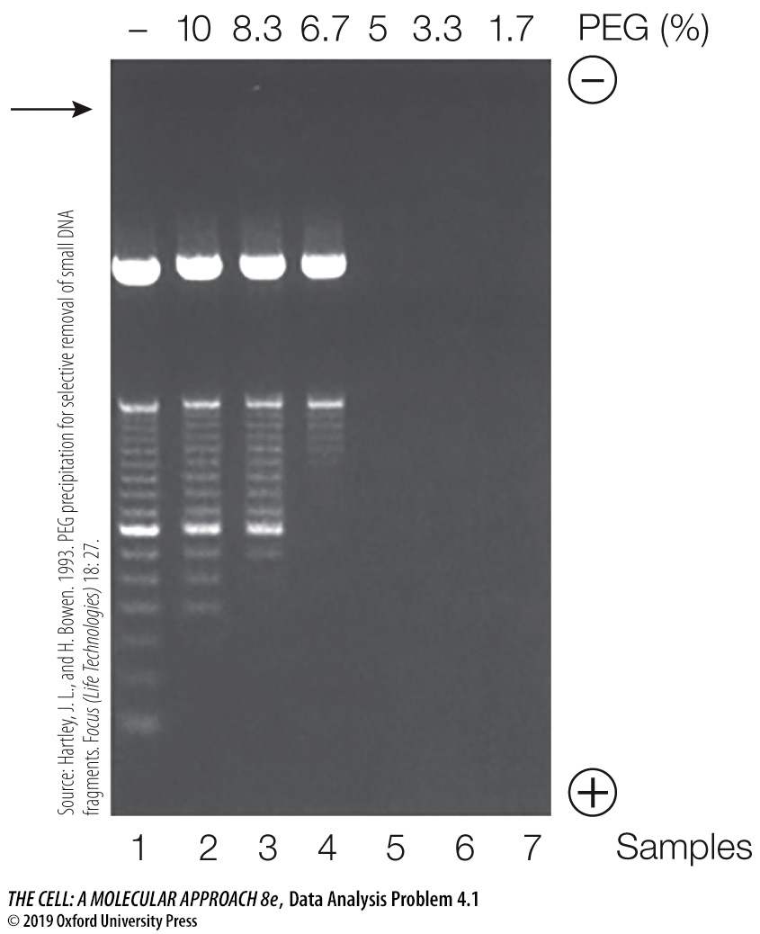

**Questions**

1. How are DNA molecules visualized in a gel after electrophoresis?

2. Why do DNA molecules migrate toward the + electrode? What determines the rate of their migration?

3. What is the effect of PEG on DNA fragments of different sizes? How is this influenced by the concentration of PEG?