Data Analysis Problem
by Marianna Pap and József Szeberényi
to accompany
The Cell: A Molecular Approach, Eighth Edition
Geoffrey M. Cooper

DAP 3.3 The Bohr Effect

This Data Analysis Problem does not appear in the textbook.

Sources: Jensen, F. B. 2004. Red blood cell pH, the Bohr effect, and other oxygenation-linked phenomena in blood O₂ and CO₂ transport. Acta Physiol. Scand. 182: 215–227.

Bohr, C., K. Hasselbalch, A. Krogh. 1904. Über einen in biologischer beziehung wichtigen einfluss, den die kohlensäurespannung des blutes auf dessen sauerstoffbedienung übt. Skand. Arch. Physiol. 16: 402–412.

Level of difficulty: High

Corresponding chapter(s) in the textbook: Chapter 3

Review the following terms before working on the problem: red blood cells, hemoglobin, partial pressure (or tension) of O₂ and CO₂

Experiment

This figure presents the results of an experiment that demonstrates the Bohr effect, a physiological phenomenon described in 1904 by the Danish scientist Christian Bohr. It also provides a classic example of the interplay between biochemistry and physiology. In this experiment, O₂ binding by dog red blood cells (y axis of the diagram) was measured at various O₂ pressures (x axis) and various CO₂ pressures (the numbers at each curve indicate the CO₂ pressure in mmHg). In the blood of the capillaries of an actively working skeletal muscle, the O₂ pressure is around 20 mmHg.

Figure

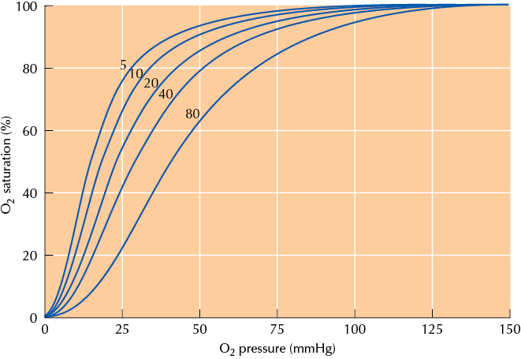

Questions

1. What protein in red blood cells is responsible for the Bohr effect?

2. How does CO₂ pressure affect the oxygen affinity of this protein?

3. What is the physiological significance of the Bohr effect in muscle capillaries?

4. What is the physiological significance of the Bohr effect in lung capillaries?

