Data Analysis Problem
by Marianna Pap and József Szeberényi
to accompany
The Cell: A Molecular Approach, Eighth Edition
Geoffrey M. Cooper

3.2 Analysis of a DNase Regulating Protein

This Data Analysis Problem is also found on page 110 of the textbook.

Source: Lesca, P., C. Paoletti. 1969. A protein inhibitor of acid deoxyribonucleases. Proc. Natl. Acad. Sci. USA 64: 913–919.

Level of difficulty: Low

Corresponding chapter(s) in the textbook: Chapter 3

Review the following terms before working on the problem: nucleases, acid hydrolases, radioactive labeling, filter precipitation assay, mononucleotides, oligonucleotides

Experiment

A regulatory protein (designated protein X) isolated from mouse liver was tested in this experiment. Protein X specifically affects acid DNase isolated from a variety of tissues. In vitro reaction mixtures were set up containing purified DNase, different concentrations of radioactively labeled DNA substrate, and different concentrations of protein X: (A) No protein X, (B) low concentration of protein X, or (C) high concentration of protein X. At the end of incubation, reaction velocities were determined by measuring the release of low-molecular-weight products (mono- and oligonucleotides). The graph shows the effect of substrate concentration and protein X on DNase activity.

Figure

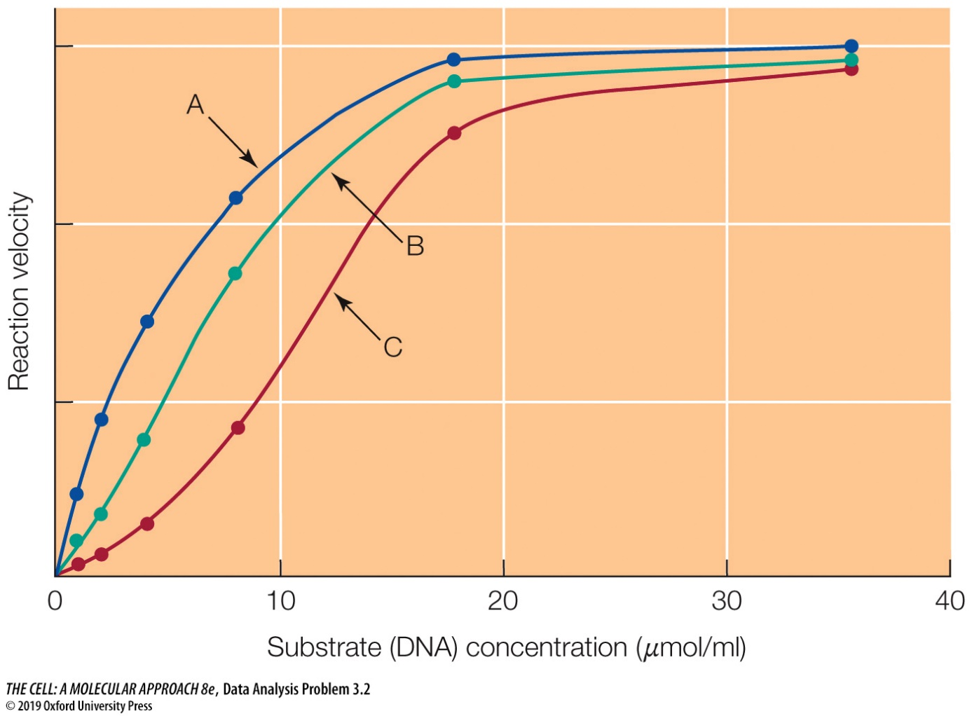

Questions

1. What must be done experimentally to assay DNase activity?

2. How does protein X affect DNase?

3. What is the relationship between the concentration of protein X and that of the substrate of the reaction?

