Data Analysis Problem
by Marianna Pap and József Szeberényi
to accompany
The Cell: A Molecular Approach, Eighth Edition
Geoffrey M. Cooper

3.1 Regulation of Aspartate Transcarbamoylase Activity

This Data Analysis Problem is also found on pages 109–110 of the textbook.

Source: Wild, J. R., S. J. Longhrey-Chen, T. S. Corder. 1989. In the presence of CTP, UTP becomes an allosteric inhibitor of aspartate transcarbamoylase. Proc. Natl. Acad. Sci. USA 86(1): 46–50.

Level of difficulty: Medium

Corresponding chapter(s) in the textbook: Chapter 3

Review the following terms before working on the problem: pyrimidine nucleotides, enzyme activity, feed-back regulation, allosteric regulation

Experiment

Figure 1 shows the metabolic pathway E.coli cells use to synthesize UTP and CTP from small molecules. A key enzyme in this process is aspartate transcarbamoylase (ATC). ATC is an enzyme that uses carbamoyl phosphate and aspartic acid to produce N-carbamoylaspartic acid, a precursor to pyrimidine nucleotides. (Note: Several other enzymes are involved in the process, indicated by the dashed arrows.)

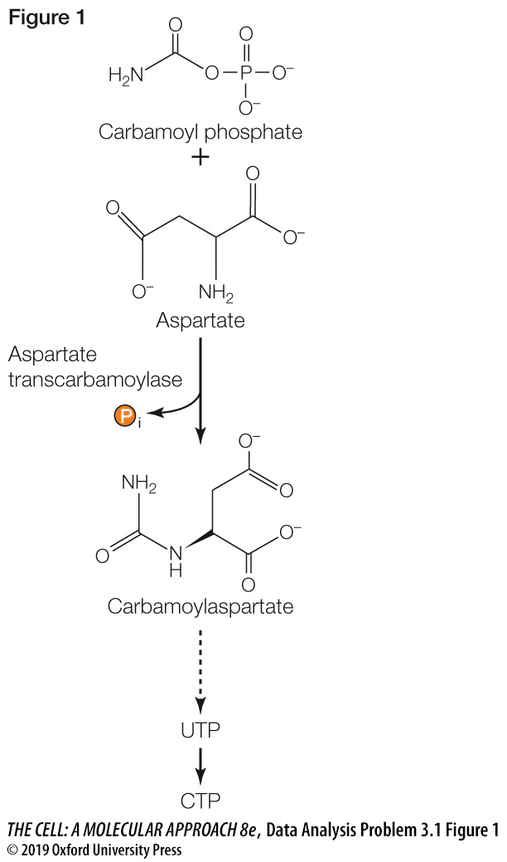

The activity of ATC was measured in vitro using carbamoyl phosphate and aspartic acid as substrates (see Figure 2). Three sets of reaction mixtures were set up, each of which contained ATC, carbamoyl phosphate, and aspartic acid:

- UTP mixture (blue ○─○): UTP was added in increasing concentrations
- CTP mixture (red ●─●): CTP was added in increasing concentrations
- CTP + UTP mixture (green ■─■): from the sample indicated by the arrow, aliquots were taken and further incubated with increasing concentrations of added UTP

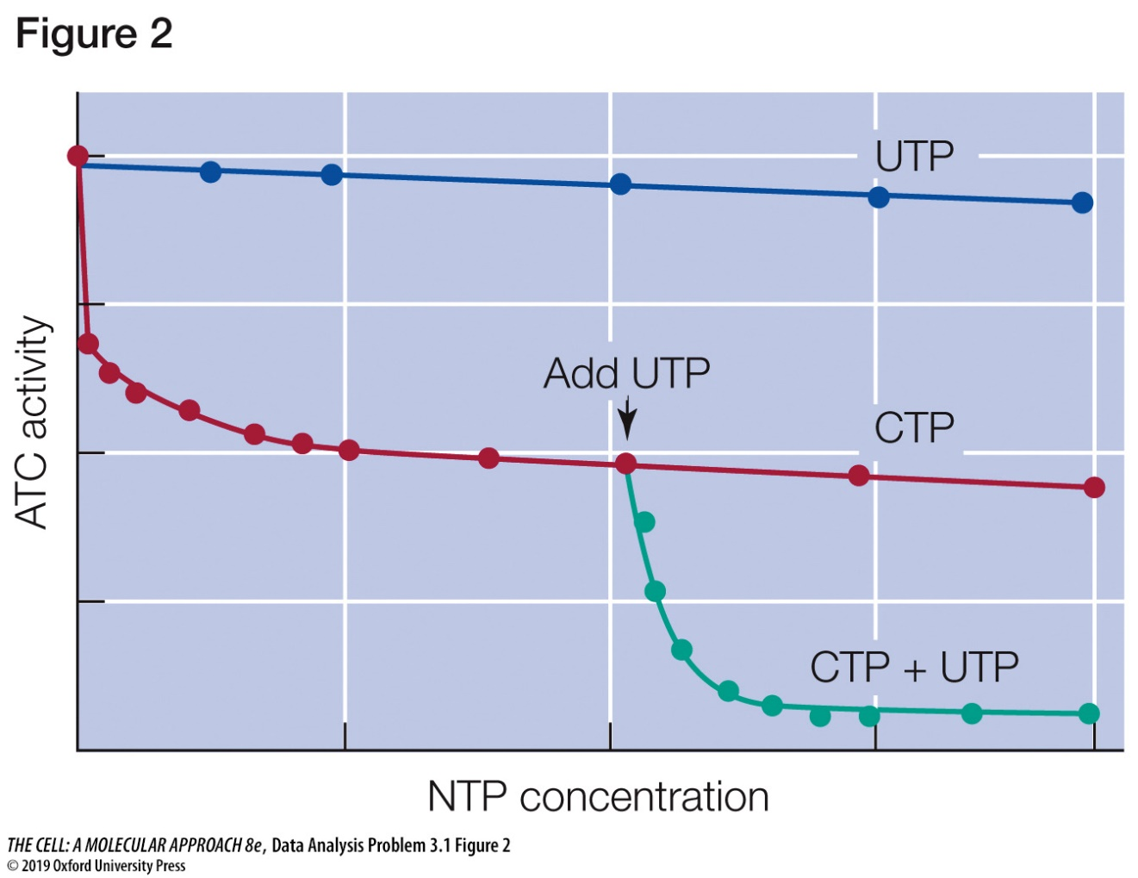

Questions

1. How does CTP affect ATC activity? What is the biological significance of this effect? What type of regulatory mechanism is involved?

2. Interpret the effect of UTP alone.

3. Compare the effect of CTP alone and when combined with UTP. What is the biological significance of this phenomenon?

4. How could you explain the effect of CTP on UTP action?

