Data Analysis Problem
by Marianna Pap and József Szeberényi
to accompany
The Cell: A Molecular Approach, Eighth Edition
Geoffrey M. Cooper

2.3 The Effect of Heating on DNA Samples

This Data Analysis Problem does not appear in the textbook.

Source: Wani, A. A., R. W. Hart. 1981. Pisum sativum endonuclease. Studies on substrate specificity and possible use as a biochemical tool. Biochim. Biophys. Acta. 655: 396–406.

Corresponding chapter(s) in the textbook: Chapter 2

Review the following terms before working on the problem: DNA structure, single- and double-stranded DNA, formamide, melting point of DNA

Experiment

Two solutions of purified mammalian DNA, one with 0% formamide (○─○) and the other with 50% formamide (●─●) were heated to 100°C. The relative fraction of single-stranded DNA in each solution was determined at several different temperatures.

Figure

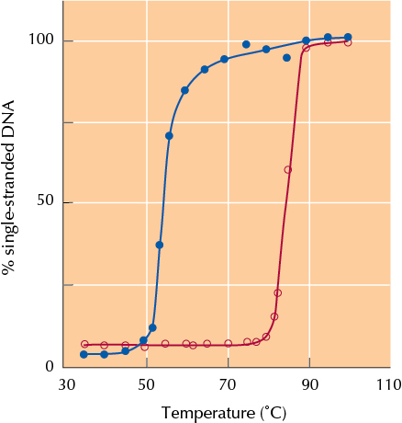

Questions

1. What process was studied in this experiment?

2. What is the easiest way to monitor this process?

3. Determine the melting point of DNA in each of the two samples.

4. What effect does formamide have in this experiment?

