Data Analysis Problem
by Marianna Pap and József Szeberényi
to accompany
The Cell: A Molecular Approach, Eighth Edition
Geoffrey M. Cooper

2.2 Electrophoretic Mobility of Hemoglobin Variants

This Data Analysis Problem is also found on page 79 of the textbook.

Source: Motulsky, A. G., M. H. Paul, E. L. Durrum. 1954. Paper electrophoresis of abnormal hemoglobins and its clinical applications: A simple semiquantitative method for the study of the hereditary hemoglobinopathies. Blood 9: 897–910.

Level of difficulty: Medium

Corresponding chapter(s) in the textbook: Chapter 2

Review the following terms before working on the problem: hemoglobin, globin genes, sickle cell anemia, point mutation, paper electrophoresis, protein staining, isoelectric point

Experiment

Hemoglobin S and hemoglobin C are abnormal forms of normal hemoglobin (hemoglobin A). Both are caused by a point mutation in the β-globin gene. Hemoglobin S is the main form of hemoglobin in the blood of sickle cell anemia patients; hemoglobin C causes a rather mild form of hemoglobinopathy. Red blood cell extracts from six individuals with different hemoglobin types were subjected to paper electrophoresis. The filter was then stained with a protein dye. Samples 4 and 5 are from the same patient, before (4) and after (5) a blood transfusion. (The origin of each sample was at the top of the membrane, as the arrow indicates; and indicate the positions and charges of the electrodes during electrophoresis.)

Figure

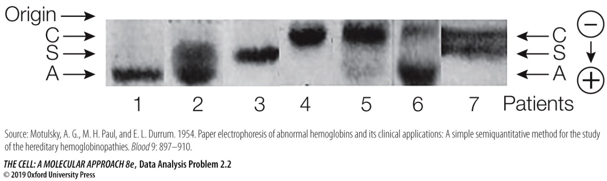

Questions

1. What was the charge on the hemoglobins in this electrophoresis buffer?

2. What characteristic of the electrophoresis buffer has the greatest effect on the charges of the hemoglobins?

3. The β-globins of HbA, HbS, and HbC differ from each other only in the sixth amino acid (from the N-terminus). Based on the electrophoretic mobilities of these hemoglobins, what types of amino acids are present at position 6 in each β-globin chain.

4. Each patient has two β-globin genes, one on each homologous chromosome. What genes are present in each patient? Which patient would you expect to be most ill and which patient most healthy?

5. Do you think the transfusion improved the condition of Patient 4 (sample 5)?

