Data Analysis Problem
by Marianna Pap and József Szeberényi
to accompany
The Cell: A Molecular Approach, Eighth Edition
Geoffrey M. Cooper

2.1 The Effect of a Reducing Agent on Protein Structure

This Data Analysis Problem is also found on pages 78–79 of the textbook.

Source: Janatova, J. 1986. Detection of disulphide bonds and localization of interchain linkages in the third (C3) and the fourth (C4) components of human complement. Biochem. J. 233: 819–825.

Level of difficulty: Medium

Corresponding chapter(s) in the textbook: Chapter 2

Review the following terms before working on the problem: tertiary and quaternary protein structure, chemical bonds, reducing agents, SDS-polyacrylamide gel electrophoresis (SDS-PAGE), protein staining

Experiment

This experiment was designed to analyze the structure of a component (called C3c protein) of the complement system, which is involved in the immune response against microorganisms. Purified C3c protein (molecular mass: 145 kD) was incubated in the presence of various concentrations of the reducing agent dithiothreitol (DTT) and then subjected to electrophoresis in a sodium dodecyl sulfate (SDS) polyacrylamide gel. SDS disrupts noncovalent bonds and polypeptides are separated by size during electrophoresis. The gel was stained with Coomassie Brillant Blue, a protein dye. The figure shows the molecular masses of intermediates and products generated by DTT treatment.

Figure

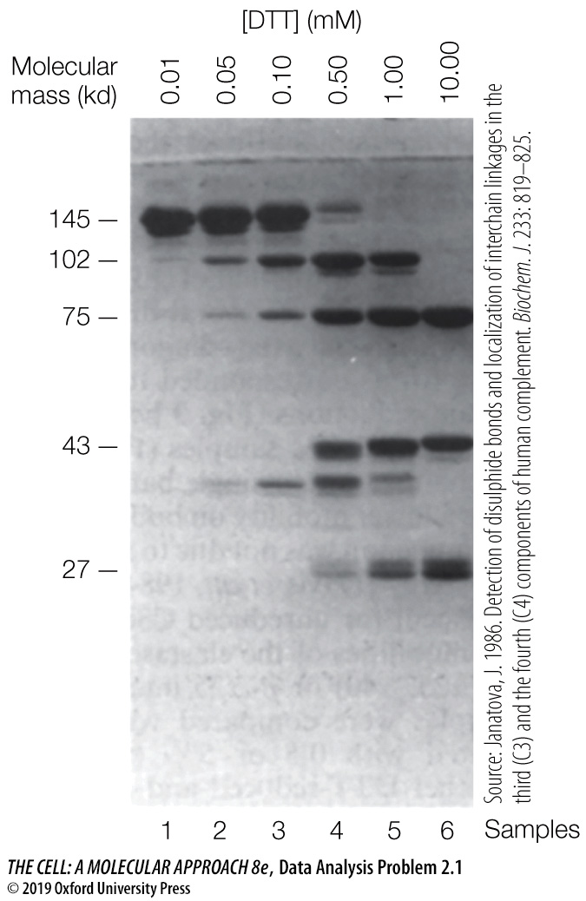

Questions

1. How many polypeptides are present in C3c? Determine their molecular masses from the figure.

2. What was the purpose of using DTT in this experiment?

3. What kind of bonds hold the polypeptides together?

4. How is the 102 kD polypeptides related to the other polypeptides species?

