Data Analysis Problem
by Marianna Pap and József Szeberényi
to accompany
The Cell: A Molecular Approach, Eighth Edition
Geoffrey M. Cooper

1.6 Analysis of Protein Synthesis in Adenovirus-Infected Cells

This Data Analysis Problem does not appear in the textbook.

Source: Velicer, L. F., H. S. Ginsberg. 1968. Cytoplasmic synthesis of type 5 adenovirus capsid proteins. Proc. Natl. Acad. Sci. USA 61: 1264–1271.

Corresponding chapter(s) in the textbook: Chapter 1 (and 2 and 9)

Review the following terms before working on the problem: adenovirus, radioactive precursors, amino acids, pulse/chase labeling, protein synthesis, protein transport, light microscopy, autoradiography

Experiment

Human cells were infected with adenovirus, and 26 hours after infection were pulse-labeled with [³H]valine for 1 minute. The sample in micrograph A was processed immediately for microscopic analysis, while cells in micrograph B were chased with excess unlabeled valine for 1 hour after the 1-minute pulse-labeling before processing for microscopic analysis.

Figure

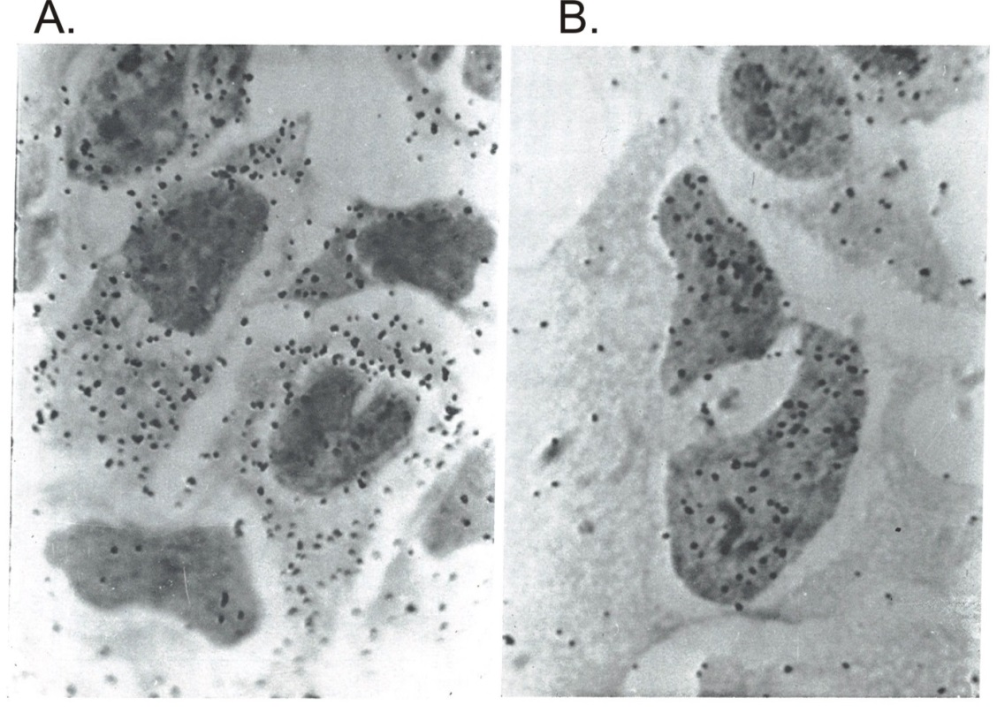
Source: Velicer, L. F., H. S. Ginsberg. 1968. Cytoplasmic synthesis of type 5 adenovirus capsid proteins. Proc. Natl. Acad. Sci. USA 61: 1264–1271.

Questions

1. What process was studied by [³H]valine labeling?

2. What is the aim of pulse-chase labeling?

3. What technique was used to detect radioactivity in the samples?

4. What conclusion can be drawn by comparing the two microscopy images?

