Data Analysis Problem
by Marianna Pap and József Szeberényi
to accompany
The Cell: A Molecular Approach, Eighth Edition
Geoffrey M. Cooper

1.5 Electron Microscopic Analysis of a Subcellular Fraction

This Data Analysis Problem does not appear in the textbook.

Source: Wolstenholme, D.R., N. J. Gross. 1968. The form and size of mitochondrial DNA of the red bean, Phaseolus vulgaris. Proc. Natl. Acad. Sci. USA 61: 245–252.

Corresponding chapter(s) in the textbook: Chapter 1 (and 12)

Review the following terms before working on the problem: differential centrifugation, homogenization, transmission electron microscopy

Experiment

The electron micrograph shows a section prepared from a cellular fraction obtained by differential centrifugation from plant cells. Homogenates of the cells were first centrifuged at 480 × g for 10 minutes, the pellet was discarded and the supernatant was centrifuged at 100,000 × g for 10 minutes. The pellet was processed for transmission electron microscopy (magnification: 27,000×).

Figure

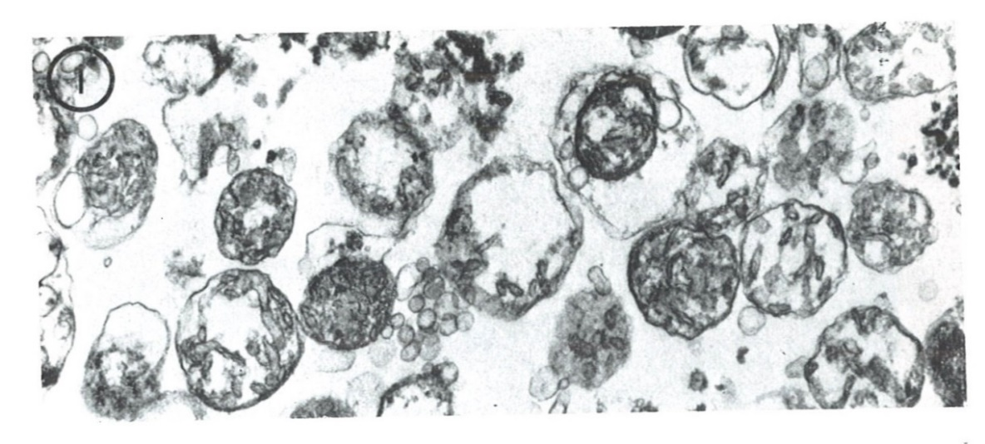
Source: Wolstenholme, D.R., N. J. Gross. 1968. The form and size of mitochondrial DNA of the red bean, Phaseolus vulgaris. Proc. Natl. Acad. Sci. USA 61: 245–252.

Questions

1. What organelles are shown in the electron micrograph?

2. What is the diameter of the organelle in the middle of the micrograph?

3. What technique could be used to detect contamination by other organelles in the sample?

