Data Analysis Problem
by Marianna Pap and József Szeberényi
to accompany
The Cell: A Molecular Approach, Eighth Edition
Geoffrey M. Cooper

1.4 Electron Microscopic Analysis of a Nuclear Fraction from Rat Liver

This Data Analysis Problem does not appear in the textbook.

Source: Liau, G., D. E. Ong, F. Chytil. 1981. Interaction of the retinol/cellular retinol-binding protein complex with isolated nuclei and nuclear components. J. Cell. Biol. 91: 63–68.

Corresponding chapter(s) in the textbook: Chapter 1 (and 11)

Review the following terms before working on the problem: differential centrifugation, nuclear fraction, detergent, fixative, electron microscopy

Experiment

Rat liver nuclei were isolated, left untreated (micrograph A) or treated with 0.5% Triton X-100, a detergent widely used in cell biology (micrograph B). Nuclei were fixed with glutaraldehyde and osmium tetroxide and studied by electron microscopy (bar, 5 μm). The phospholipid and DNA contents of the two samples were also determined and their ratios are shown under the micrographs.

Figure

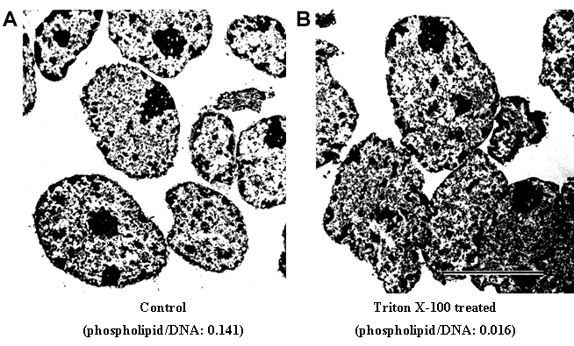

© 1981 Liau, G., D.E. Ong, F. Chytil. Originally published in Journal of Cell Biology. https://doi.org/10.1083/jcb.91.1.63

Questions

1. What is the best way to isolate a pure nuclear fraction?

2. Name the nuclear structures that contain phospholipids and DNA.

3. What was the purpose of using glutaraldehyde and osmium tetroxide in this experiment?

4. What type of electron microscopy was used in this experiment?

5. Describe the effect of Triton X-100.

6. Determine the magnification of the electron micrograph.

7. In what type of experiment would treatment of nuclei with Triton-X (or a similar detergent) be essential?

