Data Analysis Problem
by Marianna Pap and József Szeberényi
to accompany
The Cell: A Molecular Approach, Eighth Edition
Geoffrey M. Cooper

1.3 Equilibrium Density Gradient Centrifugation of
DNA Samples

This Data Analysis Problem does not appear in the textbook.

Source: Cohen, A., W. D. Fisher, R. Curtiss, H. I. Adler. 1968. DNA isolated from Escherichia coli minicells mated with F⁺ cells. Proc. Natl. Acad. Sci. USA 61: 61–68.

Corresponding chapter(s) in the textbook: Chapter 1 (and 2 and 4)

Review the following terms before working on the problem: radioactive labeling, DNA, cesium chloride, equilibrium centrifugation, DNA denaturation

Experiment

Radioactively labeled bacterial DNA was analyzed by cesium chloride (CsCl) equilibrium density gradient centrifugation. The radioactivity of fractions collected from the gradients, and the densities of the two peak fractions, were determined. Graph A: Native DNA sample; Graph B: DNA sample heated to 100°C and rapidly cooled on ice before centrifugation.

Figure

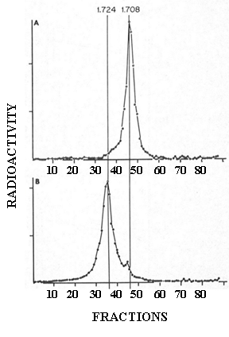

Questions

1. What was the direction of centrifugation (which fractions correspond to the bottom of the centrifuge tubes)?

2. What happens to the DNA molecules during heating and quick-chilling?

3. What conclusion can be drawn from the experiment?

