Data Analysis Problem
by Marianna Pap and József Szeberényi
to accompany
The Cell: A Molecular Approach, Eighth Edition
Geoffrey M. Cooper

1.2 Electron Microscopic of Isolated Ribosomes

This Data Analysis Problem is also found on page 42 of the textbook.

Source: Nomura, M. 1969. Ribosomes. Scientific American, October, 28–35.

Level of difficulty: Low

Corresponding chapter(s) in the textbook: Chapter 1 (and 10)

Review the following terms before working on the problem: E.coli cells, ribosomal fraction, heavy metal staining, electron microscopy

Experiment

A purified ribosomal fraction was prepared from E.coli cells and suspended in a solution with a low concentration of magnesium. This results in separation of the two subunits of ribosomes, since Mg²⁺ ions are required for ribosomal subunits to bind to each other. The ribosomal fraction was stained with uranyl formate and studied by electron microscopy (400,000-fold magnification).

Figure

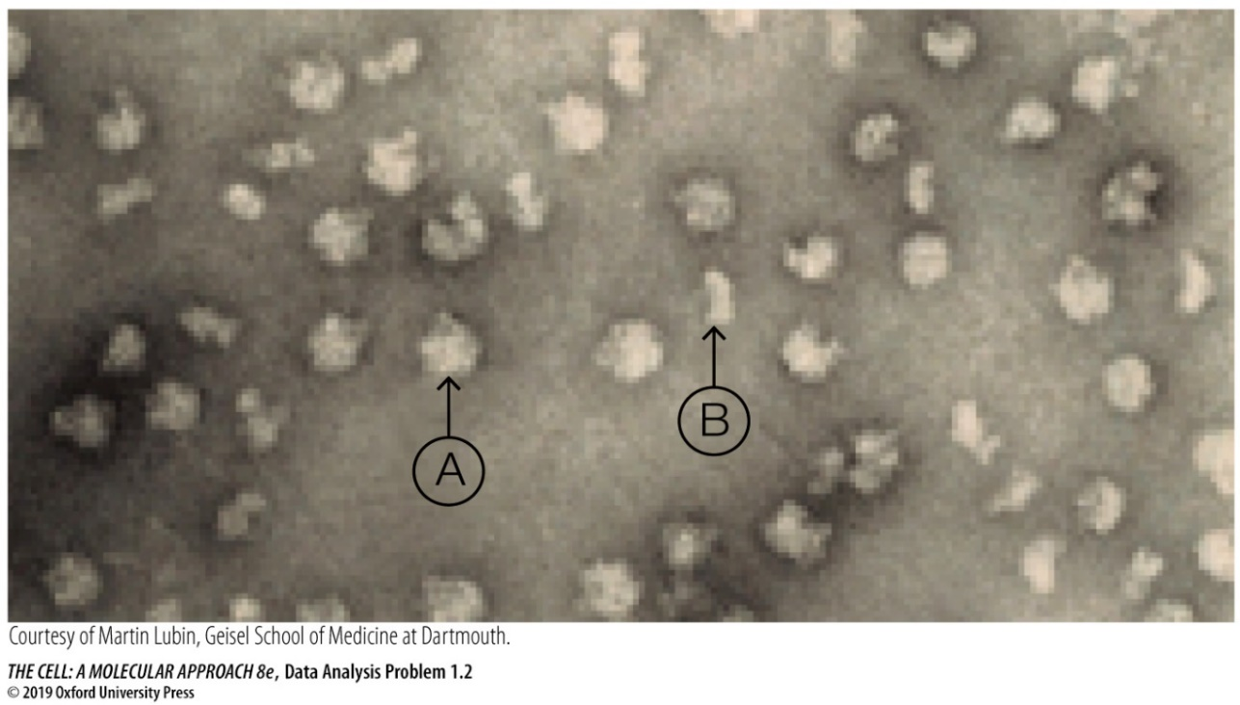

Questions

1. What kind of staining is shown in the electron micrograph?

2. What are A and B pointing to on the micrograph?

3. Determine the longest diameter of A and the shortest diameter of B.

