Active Learning Exercise 9.1
to accompany
Vertebrate Life, Tenth Edition
Pough • Janis

Why Do Fish Swim in Schools?
by Sharon L. Gilman
Coastal Carolina University
sgilman@coastal.edu

Source: This activity is based on the following paper:

Marras, Stefano, Shaun S. Killen, Jan Lindstrom, David J. McKenzie, John F. Steffensen, and Paolo Domenici. 2015. Fish swimming in schools... Behavioral Ecology and Sociobiology 69: 219–226.
https://link.springer.com/article/10.1007/s00265-014-1834-4

(Please note: The complete title is not included because it would give away the results!)

Level of Difficulty: Medium

Relevant Terminology: trophic cascades, apex predators, mesopredators, teleosts

Activity

In teams of 2–3, answer the following questions.

1. Animals often organize themselves into groups. In these cases, the benefits of being in the group must outweigh any costs. What are some possible advantages and costs of being in a group?

2. Select one of your advantages and design an experiment to test whether the fish in a school benefit as you suggest. Write out the design.

3. Swap experiments with another team. Critique their experiment.
a. What is their hypothesis?
b. Will what they propose to answer their question? Why or why not?
c. Are the variables adequately controlled? Why or why not?
d. Can you suggest improvements?

One of the advantages to schooling that you may have come up with is energy conservation. One fish may be able to draft on another, minimizing its effort to move through the water, thereby saving energy. Bicyclists do this, as do birds flying in Vs. One might assume that this benefit would vary depending where in the school a fish was: ahead of another fish, side by side, or behind.

The data shown here (Figure 1 from the paper) are from a study examining the energetics of swimming in different positions in a school. The fish are golden gray mullet, Liza
aurata. They were placed singularly (the focal fish, red dot) and then in schools of 8 in swim tunnels, with current flowing through to control swimming speed. Fifteen schools were tested. The trials were video-taped in order to analyze tail-beat frequency (TBF) and tail-beat amplitude of the focal fish when it was alone, and again while in the school, while also recording its position relative to the other fish.

Energetic costs were estimated as rates of oxygen uptake based on (i) the relationship between TBF and swimming speed, and then (ii) the relationship between swimming speed and oxygen consumption.

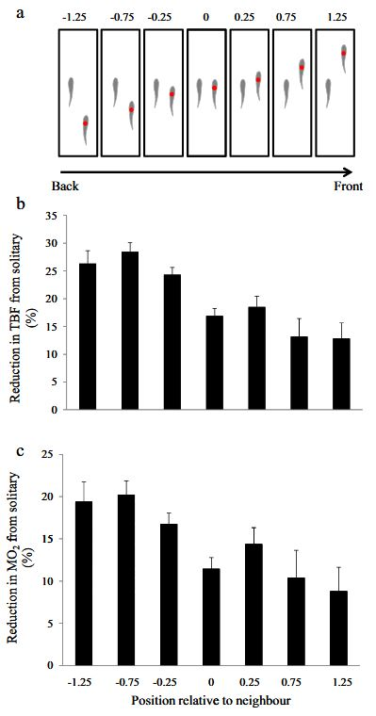

4. In your team, look at these data and describe what they demonstrate.

(The results are perhaps most surprising for the fish at the front of the school, but consider the how dolphins will “ride” the bow wave at the front of a moving boat. These fish are doing something like that.)

5. And what do these data (Figure 2 from the paper) demonstrate?

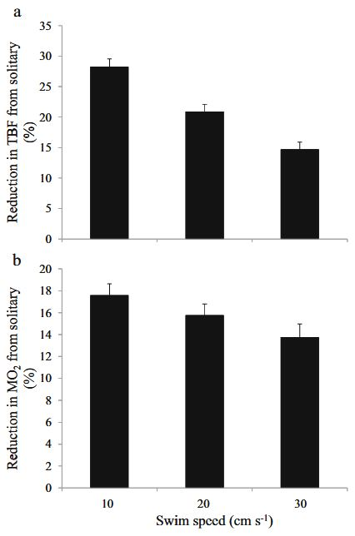

6. Based on this study, what do you conclude about fish in schools?

7. Finally, what about fishes that don’t swim in a schools? Why do you think these species don’t take advantage of the benefits a school might offer?

