Active Learning Exercise 8.1
to accompany
Vertebrate Life, Tenth Edition
Pough • Janis

Did Ray-Finned Fishes Originate in the Sea or in Fresh Water?
by Sharon L. Gilman
Coastal Carolina University
sgilman@coastal.edu

Source: This activity is based on the following paper:

Betancur-R, Ricardo, Guillermo Orti, and Robert Alexander Pyron. 2015. Fossil-based comparative analyses…….. in ray-finned fishes. Ecology Letters 18: 441–450. https://doi.org/10.1111/ele.12423

(Please note: The complete title is not included because it would give away the results!)

Level of Difficulty: Difficult

Relevant Terminology: Actinopterygii, neonatology, paleontology, phylogenetic comparative methods, phylogeny, ecological transitions

Activity

1. Fish are found in both marine and freshwater habitats, but very few groups of fish live in both successfully. Why is this?

2. According to the phylogeny of early vertebrate groups in your textbook (see Chapter 3 and Figure 3.3), the myxiniformes and petromyzontiformes are the most ancient extant fish.

a. Are they found in freshwater or marine habitats?

b. Describe any evidence suggesting they originated in one or the other of those habitats.

3. If you found a fossil fish, could you determine whether it inhabited a freshwater or marine habitat? Why, or why not?

4. How does the diversity of fishes compare for the two habitats? Consider this table:

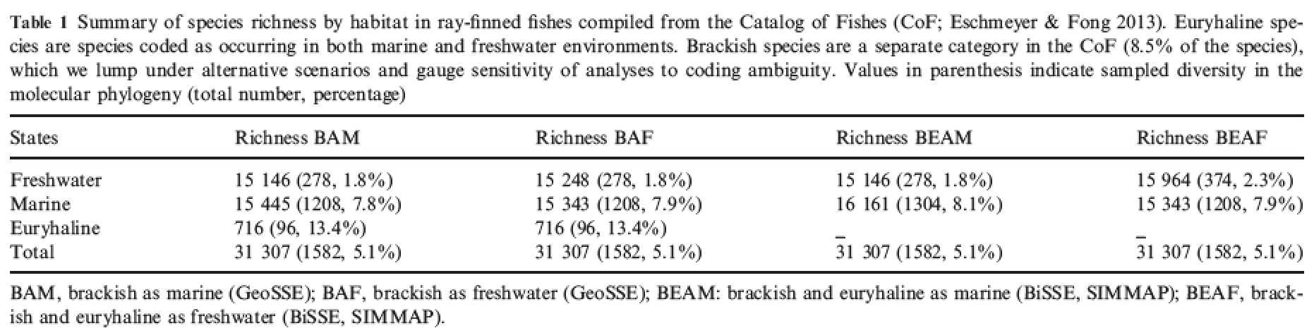

a. What do “brackish” and “euryhaline” mean?

b. How many total species of fishes are included here?

c. According to the table heading, what is indicated in the parentheses in the first column for freshwater fish?

d. Generally speaking, how does diversity of species (species richness) compare in freshwater and marine habitats?

5. Look at textbook Figure 8.1 (Phylogenetic relationships of osteichthyans). Find the stem of the Actinopterygii.

a. Which extant fish families in this group have been around the longest?

b. Where are those fish families generally found—freshwater or marine habitats?

c. What do your answers to (a) and (b) suggest about where the Actinopterygii likely started?

6. The fossil record of the Actinopterygii is quite extensive. It turns out that for the bichirs, bowfins, gars, and bonytongues, mostly freshwater fishes now, many marine fossils have been found. Does that change your answer to 5c? Why or why not?

7. Do you think that analyzing the molecular relationships of extant fishes would help answer the question of whether the early Actinopterygii were primarily marine or freshwater?

a. What would that tell you?

b. What is the difference between paleontology and neonatology?

Betancur-R et al. (2015) concluded that both the fossil record and the molecular phylogeny of extant species need to be examined to find an answer to our original question. Looking at phyologenetic relationships this way is called the “comparative method.” You’re not just looking at a single species, but the evolutionary family of species in order to ascertain who came from whom and when. This makes for a complicated analysis. In this case, it was a time-tree with both extant and fossil taxa. Habitats for each species were determined and those data included. The authors’ analysis produced these three trees.

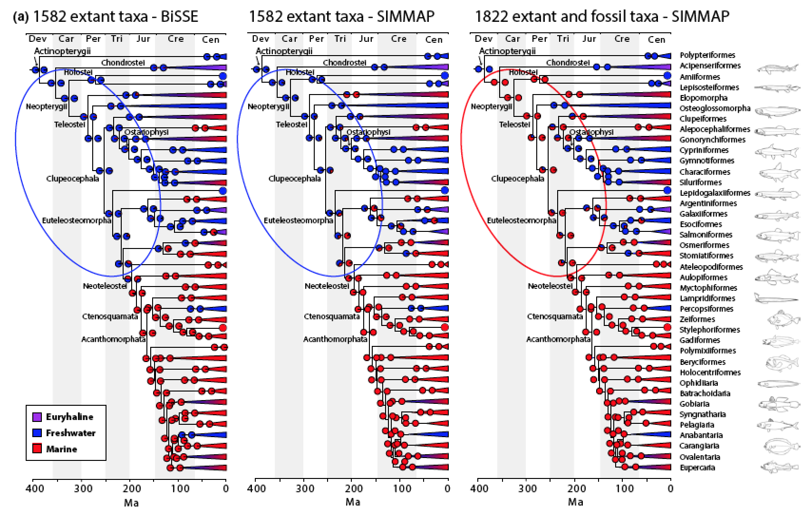

8. Consider the second and third trees.

a. What is the difference in the analyses for these two (look at the heading of each)?

b. Now look at the color coding of the earliest fishes (in the large circles). What do each of these two latter trees conclude?

c. Which do you think is more likely? Why?

