Active Learning Exercise 4.1
to accompany
Vertebrate Life, Tenth Edition
Pough • Janis

Underwater Vision in “Sea Gypsies”
by Sharon L. Gilman
Coastal Carolina University
sgilman@coastal.edu

Source: This activity is based on the following paper:

Gislen, A. and 5 others. 2003. Superior underwater vision in a human population of sea gypsies. Current Biology 13: 833–835. https://doi.org/10.1016/S0960-9822(03)00290-2

Level of Difficulty: Medium

Relevant Terminology: refraction, lens, cornea, visual acuity, retina, pupil

Introduction

It’s not surprising that humans see poorly underwater. We don’t spend much time there so our eyes have not adapted to working well in that environment.

- Based on your reading in the textbook or online, explain why human eyes don’t work well underwater.

Most fish spend all their time underwater so they need to see well there.

- How do they do that? How are their eyes different than human eyes?

Activity

Read the paper cited above and complete the following exercises.

The Moken are a tribe of so-called “sea gypsies,” tribes in Burma and the west coast of Thailand who live off of the ocean. The children of the Moken go diving for food on the sea floor and are able to see well enough to be successful at this. You explained above why most humans don’t see well underwater. In fact, average European children have an underwater visual acuity of 2.95 cycles/degree, while the Moken children do better than twice as well, with an acuity of 6.06 cycles/degree.

- How do either of those compare to human visual acuity in air?

Let’s measure it using the following steps:
[Note: Use https://petavoxel.wordpress.com/2010/02/26/cycles-per-degree/.]

- Take a Sharpie pen and draw two straight parallel lines next to each other on a white piece of paper, about a line width apart, as illustrated:

- A “cycle per degree” is equivalent to one “line pair,” which is a black/white pair taken together. Measure that and convert it to the unit of distance used on your tape measure.
- Tape your lines to the wall at eye level. Have someone stand next to the paper and hold the end of a 50-foot tape measure. You hold the tape measure, focus on the lines, and start walking backward. At some point it will become difficult, and then impossible, to see the white space between your two lines. Write down that distance.
- Divide your cycle width by the tape measure distance. You will get some tiny number. To convert that to degrees, you take the inverse tangent (use a calculator or website!). This is your degrees per cycle, so divide 1 by that number. That is your cycles per degree, or “visual acuity.” For most humans it’s between 30 and 50. And it depends on lighting. You’ll get a higher number outside during daylight hours.

So the visual acuity of the Moken children underwater still isn’t very good, but it’s significantly better than normal children. Why? Either their eyes are morphologically different, or they can accommodate to seeing underwater more than normal.

- Moken children and European children both see equally well on land. What does this tell you?

- Underwater the light is dimmer, so what reaction do you expect from your eyes in response to dimmer light? What would you expect if you looked at eyes underwater?

Here are photos of the research subjects’ eyes taken underwater.

- What do you see?

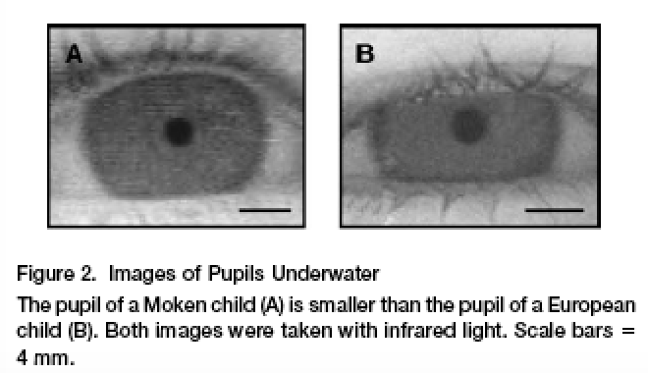

It turns out that in response to diving, the eyes of the Moken children accommodate to the water by constricting the pupil, despite the light being dimmer. In effect, they involuntarily squint when they dive, which presumably makes the images they see less bright, but also presumably shrinks the field of blurriness on the retina, improving acuity. One can learn to do this, so it’s not clear whether these children simply learn this or, given that they’ve been living this way for thousands of years, their ability is an evolutionary adaptation.

