Active Learning Exercise 3.3
to accompany
Vertebrate Life, Tenth Edition
Pough • Janis

Conflicting Results from Molecular and Morphological Phylogenies
by Sharon L. Gilman
Coastal Carolina University
sgilman@coastal.edu

Source: This activity is based on the following paper:

Near, T. J. 2009. Conflict and resolution between phylogenies inferred from molecular and phenotypic data sets for hagfish, lamprey, and gnathostomes. J. Exp. Zool. (Mol. Dev. Evol.) 312B: 749–761. https://doi.org/10.1002/jez.b.21293

Level of Difficulty: Hard

Relevant Terminology: parsimonious, phenotypic characters, phylogenetics, monophyly

Introduction

You have already seen phylogenies in the textbook, and there will be many more. These illustrate the current thinking on how the various groups of vertebrates evolved and how they are related to each other. It’s easy to start seeing these phylogenies as fact, but remember, they are hypotheses! You can come up with relationships but it’s very difficult to determine what’s actually correct. It was thought that molecular analysis would make this easier, and in some cases it has. But in many cases, being able to quantify DNA similarities between suspected relatives only complicates the matter. Sorting out the relationship between hagfish, lamprey, and the gnathostomes is one such case.

Activity

Read the paper cited above. Below are excerpts and figures from Near’s article, accompanied by short exercises designed to enhance your understanding of what he says.

1. From the Abstract:

“One of the most problematic issues in vertebrate phylogenetics is the disagreement between phenotypic and molecular inferences regarding the relationships among hagfishes, lampreys, and gnathostomes. Phenotypic characters support monophyly of lampreys and gnathostomes, whereas nearly all published analyses of molecular data sets support monophyly of hagfishes and lampreys.”

Draw a simple tree illustrating these two conflicting hypotheses.

2. From Materials and Methods section:

“Data sets for phylogenetic analyses were gathered from three of the most recently published studies and include aligned nuclear-encoded ribosomal RNA genes (Mallatt and Sullivan, ’98), aligned concatenated amino acid sequences sampled from146 nuclear-encoded genes (Delsuc et al., 2006), and 115 discretely coded phenotypic characters (Gess et al., 2006). All of these studies minimally sampled one hagfish species, one lamprey species, and the molecular data sets included several gnathostomes species.

The phenotypic data was taken from Gess et al. (2006) and is a matrix of coded character states for 115 characters assembled from previously published phylogenetic analyses of major craniate lineages (Janvier, ’96a; Donoghue et al., 2000; Donoghue and Smith, 2001).”

Explain this in your own words. In general terms, what data is this study based on?

3. The Results section includes results of “maximum parsimony analysis.” Remember that the most likely phylogenetic tree is the simplest, and there are multiple computer programs and statistical methods that will do this given characteristics of species, either phenotypic or molecular. Figure 2 from the paper presents one such set of results for the molecular data.

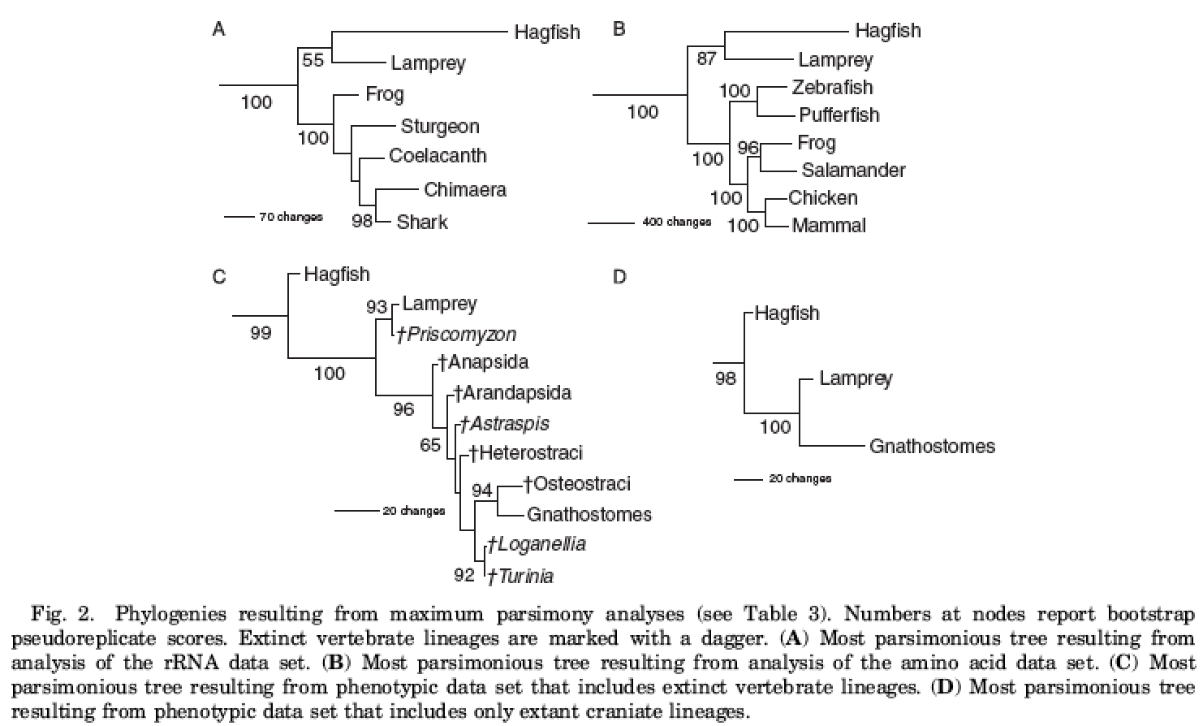

Pretend you are talking to your little brother who is in high school and has taken biology. “They’re looking to see how all these groups are related right? There is a way they actually are all related. So why are all these different rather than showing just the one right way?” Answer him.

4. Figure 4 from the Results section also shows the results of maximum parsimony analysis, but this time for molecular and phenotypic data combined.

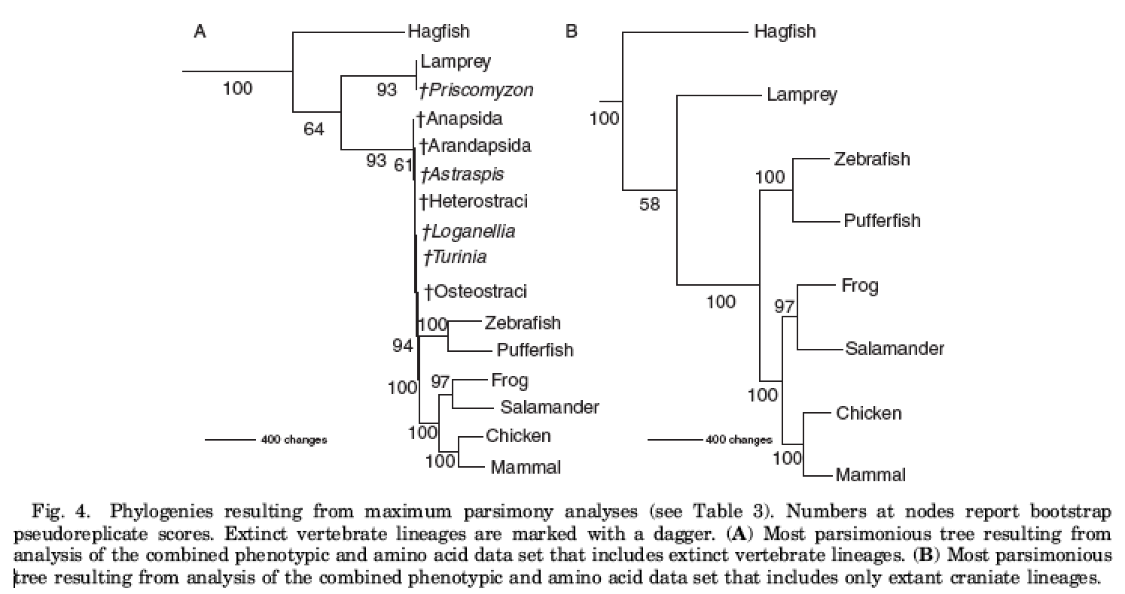

These trees combined the amino acid data with the phenotypic data. Now look at Figure 6, which combines rRNA and phenotypic data.

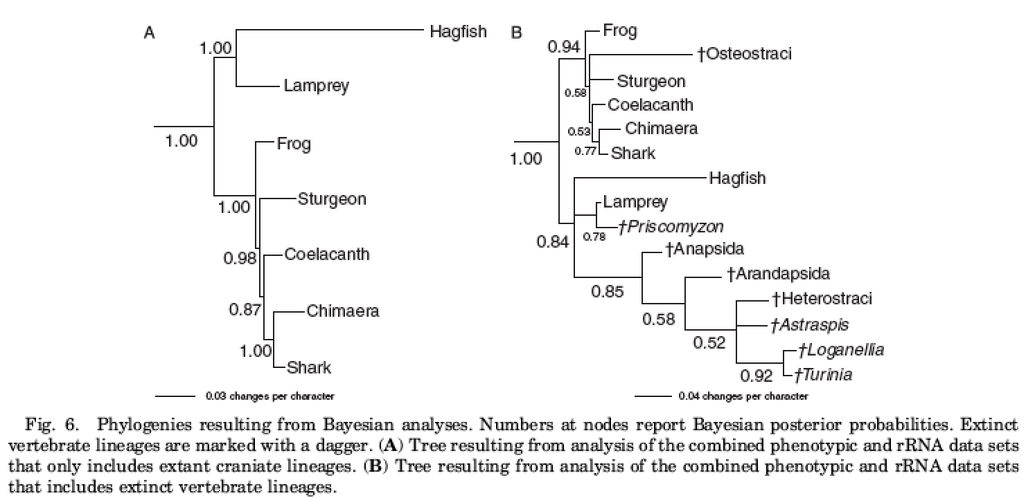

Did combining the molecular and phenotypic data clear up the confusion as to what the relationships actually are between these groups?

5. This is the final section of the final paragraph of the Discussion:

“... my study demonstrates that phylogenetic analyses that combine a relatively low number of phenotypic characters with large molecular data sets can dramatically alter the phylogenetic inference of cyclostome monophyly resulting from analyses of molecular data sets alone. Also, the short interval between the diversification events among hagfishes, lampreys, and gnathostomes, relative to the total age of the clade, presents a very hard phylogenetic problem for molecular data, leading to the erosion of phylogenetic signal and the potential for longbranch attraction. The results of the simulation studies are consistent with this scenario (Fig. 1; Table 4). Given the importance to basic organismal function of many of the phenotypic characters that support the monophyly of lampreys and gnathostomes, models of trait conservation consistent with the hypothesis of lamprey and gnathostome monophyly are more compelling than those of simple character loss offered by the hypothesis of cyclostome monophyly. The analyses and observations presented in this study indicate that the monophyly of the cyclostomes inferred from molecular phylogenetic analyses cannot be considered unequivocal.”

Translate this into your own words. What does the author conclude?

