
15
Project Management

15-2

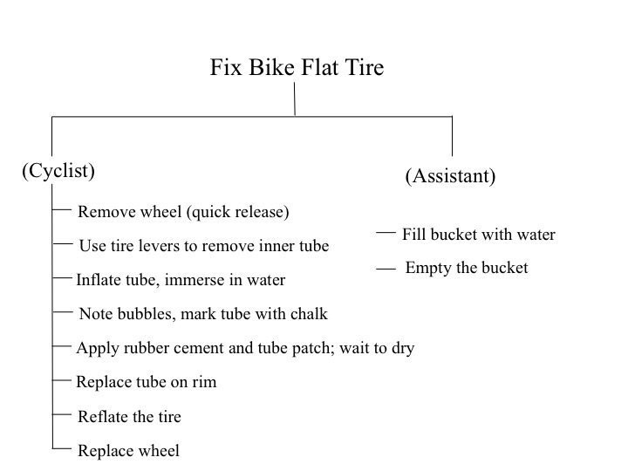

Tire levers (2 or, preferably, 3); rubber cement; rubber patch; bucket; water; chalk; bicycle pump.

15-6

Activity | Time (s)
Remove wheel | 60
Remove inner tube | 90
Fill bucket | 30
Inflate tube | 60
Mark puncture hole | 30
Patch hole | 240
Replace tube | 60
Reflate tire | 40
Replace wheel | 20
Empty Bucket | 10

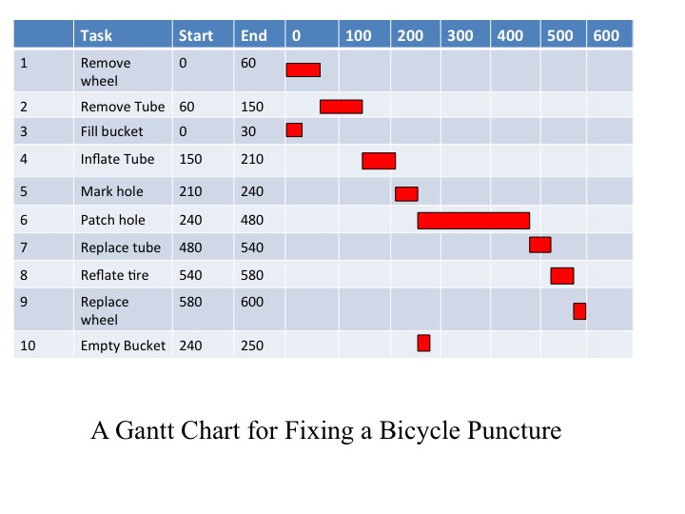
The puncture will take 600 seconds, or 10 minutes, to repair.

15-9
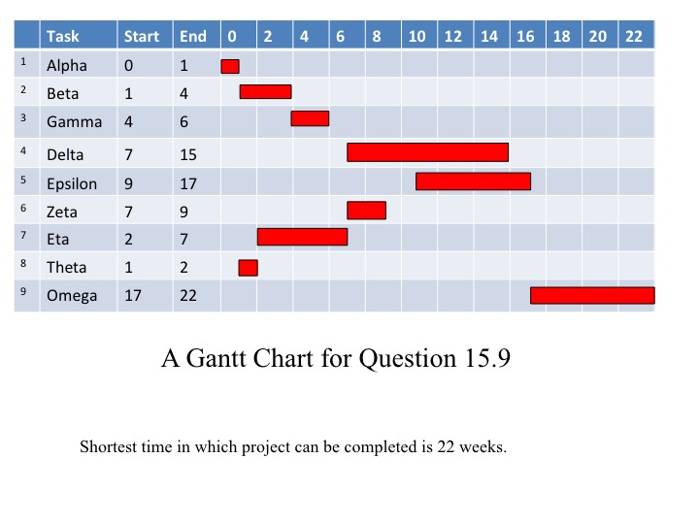

15-13

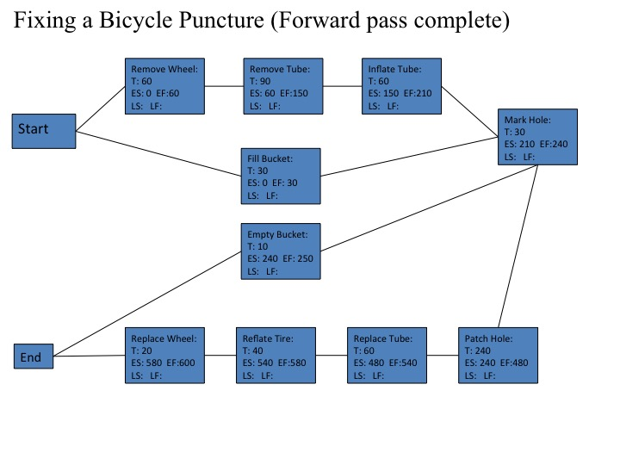

A first pass through the diagram shows that the shortest time in which the project can be completed is 600 seconds, or ten minutes. We then work backwards to determine the critical path:

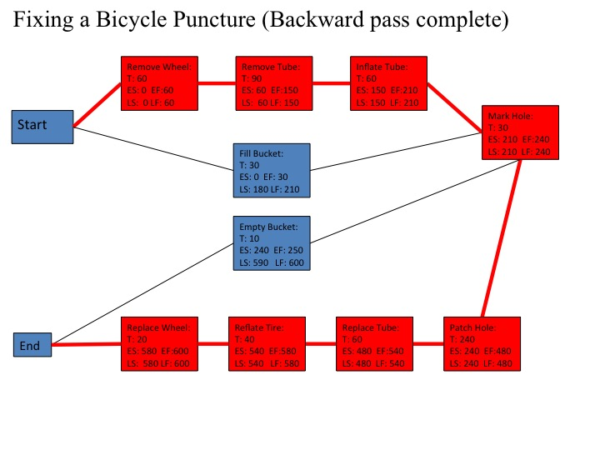

15-17

Task | Label
Phase 1 astronaut training | 1
Phase 2 astronaut training | 2
Design Earth Return Vehicle (erv) | 3
Design Mars Habitat (mh) | 4
Build erv mock-up | 5
Build erv | 6
Build mh | 7
Prepare launch site | 8
erv flight to Mars | 9
mh flight to Mars | 10
erv fuel synthesis | 11
mh digs in | 12
Astronauts’ flight to Mars | 13

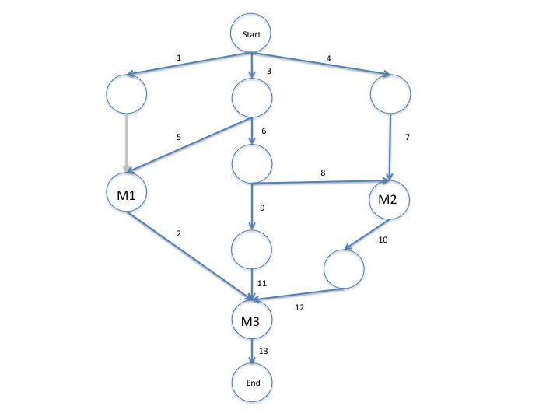

We first label the activities according to the table above, then create the AOA network shown.

So we have reduced the time to completion by a week, at a cost of $200,000, for a net profit of $50,000.

15-21 (The diagrams from this answer are needed for 15-22)

We begin by tabulating the information exchanged in the meeting:

Activity | Time (months) | Pre-requisites
1. Get pluripotent stem cells | 3 | -
2. Scale up Steel Womb | 4 | -
3a. Grow clone | 12 | 1, 2
3b. Grow clone (9m) | 9
4. Train net | 6 | -
5a. Create Chip | 2 | 4
6a. Implant chip | 0 | 5a
6a. Chip-neuron connections | 2 | 3a, 6a
5b. Program clone | 6 | 3b

There are two alternative strategies, so we will create two AON networks to represent them.

Here is the network for the implanted-chip strategy:

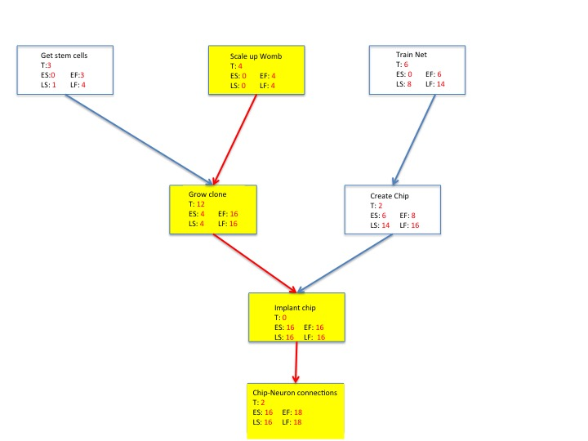

This strategy gives a time of 18 months till the clone is ready. If we use the alternative strategy of programming the clone, our AON diagram looks like this:

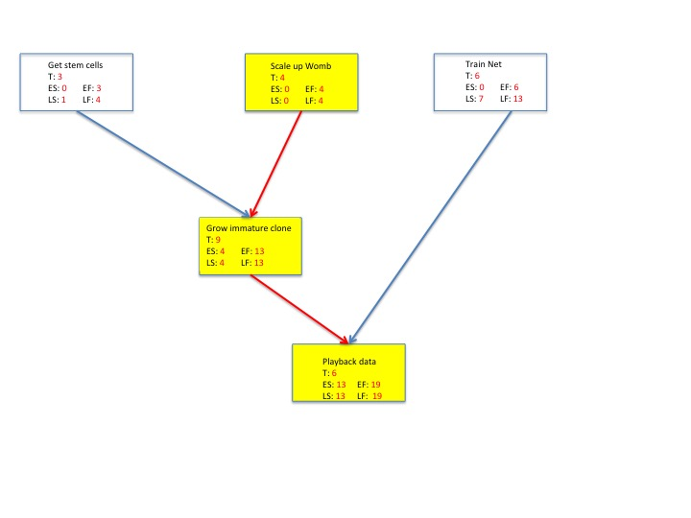

And this will give us 19 months until the clone is ready.

15-22

To answer this, we will need to refer to the diagrams in the solution to Problem 15-21. In both cases, the scaling up of the Steel Womb is on the critical path, and it can be crashed within the budget. However, as soon as we reduce the time for this activity by a month, the creation of pluripotent stem cells come onto the critical path, and this cannot be crashed. So it is worth spending $80,000 to crash the Steel Womb upgrade by a month.

