
Selection of a Minimum Attractive Rate of Return

9
9-3

- Before-tax cost of capital = [725K(0.07) + 600K(0.11) + 1200K(0.11)] / [725K + 600K + 1200K] = 0.0985 or 9.85%.

- After-tax cost of capital = 9.85% (1 – 0.3) = 6.89%.

9-4

- Before-tax cost of capital = [22M(0.18) + 9M(0.08) + 14M(0.04)] / [22M + 9M + 14M] = 0.1164 or 11.64%.

- After-tax cost of capital = 11.64% (1 – 0.3) = 8.15%

9-10

The IRR for each project is calculated using the Excel function = RATE (3, annual benefit, –first cost) since N = 3 for all projects. Then the table is sorted with IRR as the key. Do projects 3, 1 and 7 with a budget of $70,000. The opportunity cost of capital is 26.0% if based on the first project rejected.

Project | IRR | Cumulative First Cost | First Cost | Annual Benefit
3 | 36.31% | $10,000 | $10,000 | $6,000
1 | 29.92% | $30,000 | $20,000 | $11,000
7 | 26.67% | $70,000 | $40,000 | $21,000
5 | 26.01% | $95,000 | $25,000 | $13,000
4 | 20.71% | $100,000 | $5,000 | $2,400
2 | 18.91% | $130,000 | $30,000 | $14,000
6 | 18.91% | $145,000 | $15,000 | $7,000

9-13

Assume Project B in Problem 9-9 is a “new product in a new market.” From Table 9-2 the interest rate that should be used for this project is 16%.

 | First Cost | Annual Benefit | Life (years) | Salvage
Project B | $50,000 | $9,000 | 10 | 0

NPW = 0 = –50,000 + 9,000 (P/A, i, 10), so, (P/A, i, 10) = 5.5556 and interpolating
i = 12% + (3%) 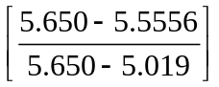 = 12.45% < 16%, so, the project should NOT be done.

9-14

Assume Project 1 in Problem 9-12 is a “new product in a foreign market.” From Table 9-2 the interest rate that should be used for this project is 20%.

 | First Cost | Annual Benefit | Life (years) | Salvage
Project 1 | $20,000 | $4,000 | 20 | 0

NPW = 0 = –20,000 + 4,000 (P/A, i, 20), so (P/A, i, 20) = 5.000 and interpolating
i = 18% + (2%) 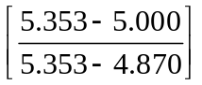 = 19.46% < 20%, so, the project should NOT be done.

9-16

(a) Approve all projects except D.

(b) Ranking Computations for NPW/Cost

Project | Cost | Uniform Benefit | NPW at 12% | NPW/Cost
A | $10 | $2.98 | $0.23 | 0.023
B | $15 | $5.58 | $4.16 | 0.277
C | $5 | $1.53 | $0.25 | 0.050
D | $20 | $5.55 | −$0.95 | −0.048
E | $15 | $4.37 | $0 | 0
F | $30 | $9.81 | $3.68 | 0.123
G | $25 | $7.81 | $1.81 | 0.072
H | $10 | $3.49 | $1.98 | 0.198
I | $5 | $1.67 | $0.73 | 0.146
J | $10 | $3.20 | $0.99 | 0.099

Ranking:

Project | Cost | Uniform Benefit | NPW at 12% | NPW/Cost
B | $15 | 0.277 | $15 | B
H | $10 | 0.198 | $25 | H
I | $5 | 0.146 | $30 | I
F | $30 | 0.123 | $60 | F
J | $10 | 0.099 | $70 | J
G | $25 | 0.072 | $95 | G
C | $5 | 0.050 | $100 | C
A | $10 | 0.023 | $110 | A
E | $15 | 0 | $125 | E
D | $20 | −0.048 | $145 | D

(c) Budget = $85,000
The first five projects (B, H, I, F, and J) equal $70,000. There is not enough money to add G, but there is enough to add C and A. Alternately, one could delete J and add G. So two possible selections are:

B H I F G NPW(14%) = $28.36
B H I F J C A NPW(14%) = $28.26

For $85,000, maximize NPW. Choose: B, H, I, F, and G.

9-17

(a) Cost to maximize total “ohs”—no budget limitation Select the most appropriate gift for each of the seven people

Recipient | Gift | Oh Rating | Cost
Father | Shirt | 5 | $20
Mother | Camera | 5 | $30
Sister | Sweater | 5 | $24
Brother | Camera | 5 | $30
Aunt | Candy | 5 | $20
Uncle | Sweater | 4 | $24
Cousin | Shirt | 4 | $20
Total |  |  | $168

Cost of Best Gifts = $168

(b) This problem differs from those described in the book where a project may be rejected by selecting the do-nothing alternative. Here, each person must be provided a gift. Thus while we can move the gift money around to maximize “ohs,” we cannot eliminate a gift. This constraint eliminates the NPW – p (PW of Cost) or Ohs – P (Cost) technique.

The best solution is to simplify the problem as much as possible and then to proceed with incremental analysis. The number of alternatives may be reduced by observing that since the goal is to maximize “ohs,” for any recipient one should not pay more than necessary for a given number of “ohs,” or more dollars for fewer “ohs.”
For example, for Mother the seven feasible alternatives (the three 0–oh alternatives are not feasible) are:

Alternative | Cost | Ohs
1 | $20 | 4
4 | $20 | 3
5 | $24 | 4
6 | $30 | 5
8 | $16 | 3
9 | $18 | 4
10 | $16 | 2

Careful examination shows that for five “ohs,” one must pay $30, for four “ohs,” $18, and $16 for three “ohs.” The other three and four oh alternatives cost more, and the two alternative costs the same as the three oh alternatives.

Thus for Mother the three dominant alternatives are:

Alternative | Cost | Ohs
6 | $30 | 5
9 | $18 | 4
10 | $16 | 2

All other alternatives are either infeasible or inferior.

If the situation is examined for each of the gift recipients, we obtain:
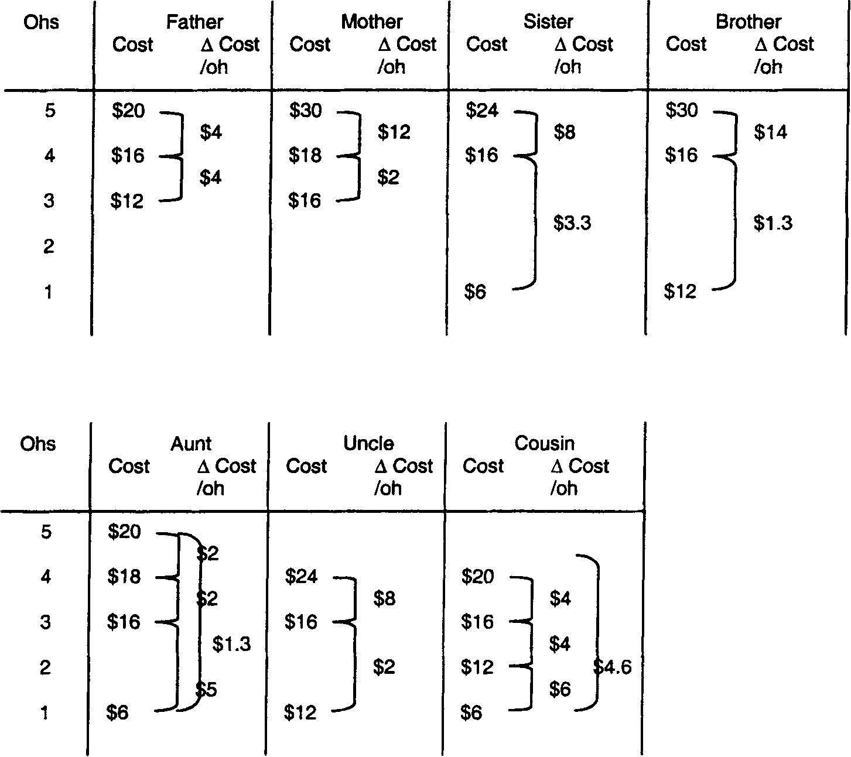
In part (a) we found that the most appropriate gifts cost $168. This table confirms that the gifts with the largest oh for each person cost $20 + $30 + $24 + $30 + $20 +$24 + $20 = $168. (This can be found by reading across the top of the table on the previous page.)

For a budget limited to $112 we must forego increments of Cost/Oh that consume excessive dollars. The best saving available is to go from a five-oh to a four-oh gift for Brother, thereby savings $14. This makes the cost of the seven gifts = $168 − $14 = $154. Further adjustments are required, first on Mother, then Sister, then Father and finally a further adjustment of Sister. The selected gifts are:

Recipient | Gift | Oh Rating | Cost
Father | Shirt | 5 | $20
Mother | Book | 4 | $18
Sister | Magazine | 4 | $16
Brother | Magazine | 4 | $16
Aunt | Candy | 5 | $20
Uncle | Necktie | 3 | $16
Cousin | Calendar | 1 | $6
Total |  | 26 | $112

(c) For a budget of $90 the process described above must be continued. The selected gifts are:

Recipient | Gift | Oh Rating | Cost
Father | Cigars | 3 | $12
Mother | Book | 4 | $18
Sister | Magazine | 4 | $16
Brother | Magazine | 4 | $16
Aunt | Calendar | 1 | $6
Uncle | Necktie | 3 | $16
Cousin | Calendar | 1 | $6
Total |  | 20 | $90

