
Benefit/Cost Ratio and Other Analysis Techniques

8
8-4

Cost of building the overpass = $1.8 million
Life of the overpass = 30 years
Salvage value at the end of the life = $100,000
Rate of interest to be considered = 6%

Annual benefit to the public:

Trucks = (Number of trucks) × (Saving of time in minutes) × ($ savings for 1 minute)
= 400 × 2 × 18/ 60
= 800 × 18/60
= 800 × 0.3
= $240/day
Others = (Number of other vehicles) × (Saving of time in minutes) × ($ savings for 1 minute)
= 600 × 2 × 5/60
= 1,200 × 0.083
= 99.99 = $100/day

Total = Trucks + Other vehicles
= $240 + $100
= $340/day

Thus, annual benefit = $340 × 365 = $124,100

Annual benefit to the province:

Annual investigation cost (due to accidents) = $6,000

Annual benefit to the railway:

Annual guarding expenses = $48,000
Annual accident claim = $60,000
Total annual benefit = $108,000

Combined benefit to all the three = Benefits to (Public + Province + Railways)
= $124,000 + $6,000 + $108,000
= $238,000

To assess the feasibility of the construction of the overpass, we must compute the B/C ratio using the PW approach.

PW of benefits = Annual benefit (P/A, 6%, 30) + Salvage (P/F, 6%, 30)
= $238,100 (P/A, 6%, 30) + $100,000 (P/F, 6%, 30)
= $238,100 (13.765) + $100,000 (0.1741)
= $3,277,446.50 + $17,410
= $3,294,856.50

PW of costs = $1,800,000

B/C ratio = PW of benefits/PW of costs
= $3,294,856.5/$1,800,000
= 1.8305

Since the B/C ratio is greater than 1, the overpass should be built.

The cost should be shared in the proportion of the benefits.

PW of the cost = $1,800,000 − $100,000 (P/F, 6%, 30)
= $1,800,000 – $100,000 (0.1741)
= $1,782,590

Amount the railway should pay = 1,782,590 × (108,000/238,100)
= 1,782,590 × 0.4536
= $808,567

8-9

Initial cost = $100,000
Additional cost at the end of Year 1 = $150,000
Benefit at end of Year 1 = 0
Benefit at the end of Years 2–10 = $20,000 per year
Time = 10 years
Interest rate = 7%

PW of benefits = Benefit [P/A, 7%, 9 (since benefit is from 2 to 10 years)] (P/F, 7%, 1) (since it is for only 1 year)]
= $20,000 (6.515) (0.9346)
= $20,000 (6.089)
= $121,778

PW of costs = Initial cost + Additional cost after 1 year (P/F, 7%, 1)
= $100,000 + $150,000 (0.93461)
= $100,000 + $140,191.5
= $240,191

B/C ratio = PW of benefits/PW of costs
= $121,778.38/$240,191
= 0.507

8-11

The problem can be solved using calculus, though we can also use a spreadsheet to solve it graphically. The project’s “optimal size” is the size at which the B/C ratio is at a maximum.

The first step is to calculate benefits for a range of costs. We can re-arrange the given equation to get:

PW(benefits) = [-44+22 × PW(costs)]^{0.5}

Taking a range of costs, we use this to plot Figure 8.11(i):

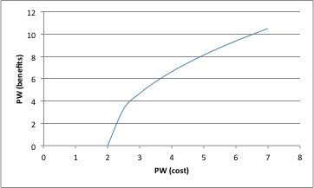

Figure 8.11(i)

Using this set of values of the present worths of benefits and costs, we now plot a second graph, of PW(costs) versus B/C ratio:

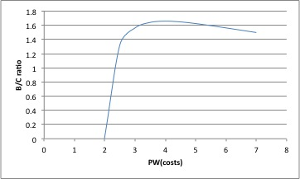

Figure 8.11 (ii)

From this we can see that the B/C ratio reaches a maximum of 1.66 when the present worth of costs is $4,000,000.

8-13

Annual Travel Volume = (2,500) (365) = 912,500 cars/year

The High Road
1st Cost = $200,000 (35) = $7,000,000
Annual Benefits = 0.015 ($912,500)(35) = $479,063
Annual O & M Cost = $2,000 (35) = $70,000
The Low Road
1st Cost = $450,000 (10) = $4,500,000
Annual Benefits = 0.045 ($912,500) (10) = $410,625
Annual O & M Cost = $10,000 (10) = $100,000

These are two mutually exclusive alternatives, so we use an incremental analysis process.

Rank Order based on denominator = Low Road, High Road

 | Do Nothing-vs.-Low | Low-vs.-High
Δ 1st Cost | $4,500,000 | $2,500,000
Δ Annual Benefits | $410,625 | $68,438
Δ Annual O & M Costs | $100,000 | −$30,000
Δ B / Δ C | 1.07ª | 0.61^{b}
Justified? | Yes | No

Recommend investing in the Low Road—it is the last justified increment.
ª [($410,625 − $100,000) ($15,456)]/$4,500,000 = 1.07
^{b} [($68,438 + $30,000) ($15,456)]/$2,500,000 = 0.61

8-16

This problem requires some thought on how to structure the analysis. This is a situation of providing the necessary capacity when it is needed—in other words Fixed Output. Computing the cost is easy, but what is the benefit?

We cannot compute the B/C ratio for either alternative, but we can compute the incremental B/C ratio on the difference between alternatives.

We start with the assumption that we’re going to build the full-capacity tunnel, and consider the B/C ratio of upgrading to the half-capacity tunnel. This upgrade has the benefit of saving us $200,000 now, $4,000 in lining repair in 10 and 20 years’ time, but it will then cost us $400,000 for the second tunnel, and an additional $12,000 for lining repairs in 30 and 40 years’ time

So ΔB/ΔC (all in $000)
= (200+4((P/F, 0.05,10)+ ((P/F, 0.05,20)))/(400(P/F, 0.05,20)+12((P/F, 0.05,30)+ P/F, 0.05,40)))
= (200+4((0.6139) + (0.3768))) / (400(0.3768) + 12((0.2324) + (0.1420)))
= 204.0/155.2 = 1.314

So the better choice is to build the half-capacity tunnel now.

8-17

(a)
 | 1 | 2 | 3 | 4 | 5 | 6
AW Costs (sponsor) | 15.5 | 13.7 | 16.8 | 10.2 | 17 | 23.3
AW Benefits (users) | 20 | 16 | 15 | 13.7 | 22 | 25
B/C Ratio | 1.29 | 1.17 | 0.89 | 1.34 | 1.29 | 1.07

We can eliminate project #3 from consideration. Our rank order is 4, 2, 1, 5, and 6.

 | DN – 4 | 4 – 2 | 4 – 1 | 1 – 5 | 5 – 6
Δ AW Costs (sponsor) | 10.2 | 3.5 | 5.3 | 1.5 | 6.3
Δ AW Benefits (users) | 13.7 | 2.3 | 6.3 | 2 | 3
Δ B/C Ratio | 1.34 | 0.66 | 1.19 | 1.33 | 0.48
Justified? | Yes | No | Yes | Yes | No

Choose Alternative 5 because it is associated with the last justified increment of investment.

(b) If these alternatives were independent and not mutually exclusive, we would proceed with all of those having a B/C ratio > 1, that is, with 1, 2, 4, 5 and 6.

8-19

Upfront investment required = $275,000
The benefit available in the first year is $10,000; thereafter, it increases by $2,000 each year.

The upfront investment will break even only if PW of costs = PW of benefits or,
PW of benefits – PW of costs = 0

Let the end-of-year benefit in the year we start the project = X

X (P/A, 6%, 15) + $2,000 (P/G, 6%, 15) – $275,000 = 0
9.712 X + $2,000 (57.555) = $275,000
X = [$275,000 – $2,000 (57.555)]/9.712
= ($275,000 – $115,110)/9.712
= 159,890/9.712
= $16,463

It is clear that the investments should be made only when the benefit at the end of the first year is greater than $16,643, which happens only in 2020. Hence, no construction should be done before 2020.

Now we must decide whether the construction should take place in 2020 or 2021. To answer this, we will compute the NPW for both the years:

NPW in 2020 = $18,000 (P/A, 6%, 15) + $2,000 (P/G, 6%, 15) – $275,000
= $18,000 (9.712) + $2,000 (57.555) – $275,000
= $174,816 + $115,110 – $275,000
= $14,926

NPW in 2021 = [$20,000 (P/A, 6%, 15) + $2,000 (P/G, 6%, 15) – $275,000] (P/F, 6%, 1)
= [$20,000 (9.712) + $2,000 (57.555) – $275,000] (0.9434)
= ($194,240 + $115,110 – $275,000) (0.9434)
= $34,350 (0.9434)
= $32,406

Since the NPW is greater in 2021, the construction should take place in 2021.

8-21

(a) To find the justified capital expenditure, we first need to find the present worth of the benefits and the present worth of the costs.

PW of benefits = $600,000 (P/A, 5%, 10) + $640,000 (P/A, 5%, 10) (P/F, 5%, 10) +
$660,000 (P/A, 5%, 10) (P/F, 5%, 20) + $660,000 (P/A, 5%, 10)
(P/F, 5%, 30) + $700,000 (P/A, 5%, 10) (P/F, 5%, 40)

= $600,000 (7.722) + $640,000 (7.722) (0.6139) + $660,000 (7.722)
(0.3769) + $660,000 (7.722) (0.2314) + $700,000 (7.722) (0.1420)

= $4,633,200 + 3,033,942 + 1,920,878 + 1,179,334 + 767,566

= $11,534,922

For a benefit-cost ratio = 1, PW of benefit = PW of costs

The justified capital expenditure = PW of benefit – PW of costs
= $11,534,922– $15,000 (P/A, 5%, 50)
= $11,534,922– $15,000 (18.256)
= $11,534,922– $273,840
= $11,261,082

(b) PW of benefits = $600,000 (P/A, 8%, 10) + $640,000 (P/A, 8%, 10) (P/F, 8%, 10) +
$660,000 (P/A, 8%, 10) (P/F, 8%, 20) + $660,000 (P/A, 8%, 10)
(P/F, 8%, 30) + $700,000 (P/A, 8%, 10) (P/F, 8%, 40)

= $600,000 (6.710) + $640,000 (6.710) (0.4632) + $660,000 (6.710)
(0.2145) + $660,000 (6.710) (0.0994) + $700,000 (6.710) (0.0460)

= $4,026,000 + $1,989,166 + $949,934 + $440,202 + $216,062

= $7,621,365

The justified capital expenditure = PW of benefit – PW of costs
= $7,621,365 – $15,000 (P/A, 8%, 50)
= $7,621,365 – $15,000 (12.233)
= $7,621,365 – $183,495
= $7,437,870
8-27

Payback Period = Cost/Annual Benefit = $3,800/4($400) = 2.4 years

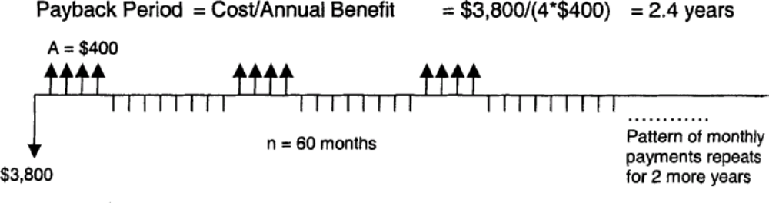

$3,800 = $400 (P/A, i%, 4) + $400 (P/A, i%, 4) (P/F, i%, 12) + $400 (P/A, i%, 4) (P/F, i%, 24) + $400 (P/A, i%, 4) (P/F, i%, 36) + $400 (P/A, i%, 4) (P/F, i%, 48)

$3,800 = $400 (P/A, i%, 4) [1 + (P/F, i%, 12) + (P/F, i%, 24) + (P/F, i%, 36) + (P/F, i%, 48)]

Try i = 3%
P(3%) = $400 (3.717) [1 + 0.7014 + 0.4919 + 0.3450 + 0.2420] = $1,486.80 [2.7803] = $4,134 i too low

Try i = 4%
P(4%) = $400 (3.630) [1 + 0.6246 + 0.3901 + 0.2437 + 0.1522]
= $1,452 [2.4106]
= $3,500 i too high

Try i = 3.5%
P(3.5%) = $400 (3.673) [1 + 0.6618 + 0.4380 + 0.2898 + 0.1918]
= $1,469.20 [2.5814]
= $3,798

So i = 3.5% per month
Nominal Rate of Return = 12 (3.5%) = 42%

8-29

Lease: A = $5,000/yr

Purchase:
$7,000 A = $3,500
S = $500

(a) Payback Period
Cost = $7,000
Benefit = $1,500/yr + $500 at any time
Payback = ($7,000 – $500)/$1,500 = 4.3 years

(b) Benefit–Cost Ratio
B/C = EUAB/EUAC
= [$1,500 + $500 (A/F, 10%, 6)]/[$7,000 (A/P, 10%, 6)]
= [$1,500 + $500 (0.1296)]/[$7,000 (0.2296)]
= 0.97

8-30

(a)
 | Increment B – A
Δ Cost | $300
ΔEUAB | $50

Incremental Payback = Cost/EUAB = $300/$50 = 6 years

(b) ΔB/ΔC = [$50 (P/A, 12%, 8)]/$300= 0.83
Reject B and select A.

