
Economic Decision, Engineering Costs, and Cost Estimating
1
1-2

Of the three alternatives, the $150,000 investment problem is most suitable for economic analysis. There are not enough data to figure out how to proceed, but if the “desirable interest rate” were 9%, then foregoing it for one week would mean an immediate loss of:

1/52 (0.09) = 0.0017= 0.17%

It would take over a year at 0.15% more to equal the 0.17% foregone now.

The candy bar problem is suitable for economic analysis. Compared to the investment problem it is, of course, trivial.

Joe’s problem is a real problem with serious economic consequences. The difficulty may be in figuring out what one gains if he pays for the fender damage, instead of having the insurance company pay for it.

1-38

The fundamental concept here is that we will trade an hour of study in one subject for an hour of study in another subject so long as we are improving the total results. The stated criterion is to “get as high an average grade as possible in the combined classes.” (This is the same as saying “get the highest combined total score.”)

Since the data in the problem indicate that additional study always increases the grade, the question is how to apportion the available 15 hours of study among the courses. One might begin, for example, assuming five hours of study on each course. The combined total score would be 190.

Decreasing the study of mathematics one hour reduces the math grade by 8 points (from 52 to 44). This hour could be used to increase the physics grade by 9 points (from 59 to 68). The result would be:

Math | 4 hours | 44
Physics | 6 hours | 68
Engr. Econ. | 5 hours | 79
Total | 15 hours | 191

Further study would show that the best use of the time is:

Math | 4 hours | 44
Physics | 7 hours | 77
Engr. Econ. | 4 hours | 71
Total | 15 hours | 192

1-45

- 500 parts
Average cost = $13
Marginal cost = $13

- 1500 parts
Average cost = ((1000)($13) + (500)($12)) / 1500 = $ 12.67
Marginal cost = $12

(c) 2500 parts
Average cost = ((1000)($13) + (1500)($12)) / 2500 = $12.40
Marginal cost = $12

(d) 3500 parts
Average cost = ((1000)($13) + (2000)($12) + 500($11)) / 3500 = $12.14
Marginal cost = $11

1-47

Unit Manufacturing Cost

(a) Daytime Shift = ($2,000,000 + $9,109,000)/23,000
= $483/unit

(b) Two Shifts = [($2,400,000 + (1 + 1.25) ($9,109,000)]/46,000
= $497.72/unit

Second shift increases unit cost.

1-48

x = number of maps dispensed per year

(a) Fixed Cost (I) = $1,000
(b) Fixed Cost (II) = $5,000
(c) Variable Costs (I) = 0.900
(d) Variable Costs (II) = 0.100
(e) Set Total Cost (I) = Total Cost (II)
$1,000 + 0.90x = $5,000 + 0.10x
thus x = 5,000 maps dispensed per year.
The student can visually verify this from the figure.
(f) System I is recommended if the annual need for maps is <5,000
(g) System II is recommended if the annual need for maps is >5,000
(h) Average Cost @ 3,000 maps:
TC(I) = (0.9) (3.0) + 1.0 = 3.7/3.0 = $1.23 per map
TC(II) = (0.1) (3.0) + 5.0 = 5.3/3.0 = $1.77 per map
Marginal Cost is the variable cost for each alternative, thus:
Marginal Cost (I) = $0.90 per map
Marginal Cost (II) = $0.10 per map

1-50

(a) x = number of visitors per year
Break even when: Total Costs (Tugger) = Total Costs (Buzzer)
$10,000 + $2.5x = $4,000 + $4.00x
x = 400 visitors is the breakeven quantity

(b) See the figure below:

X | Y1 (Tug) | Y2 (Buzz)
0 | 10,000 | 4,000
4,000 | 20,000 | 20,000
8,000 | 30,000 | 36,000

$10,000
$20,000
$30,000
$40,000
0 2,000 4,000 6,000 8,000
Visitors per year
Y₂ = 4,000 + 4x
Y₁ = 10,000 + 2.5x
Buzz Preferred
Tug Preferred
Y₁ (Tug)

Y₂ (Buzz)

1-53

x = units/year
By hand = Painting Machine
$1.40x = $15,000/4 + $0.20
x = $5,000/1.20 = $4,167 units

1-55

C = $3,000,000 − $18,000Q + $75Q²
Where C = Total cost per year
Q = Number of units produced per year
Set the first derivative equal to zero and solve for Q.
dC/dQ = −$18,000 + $150Q = 0
Q = $18,000/$150 = 120

Therefore total cost is a minimum at Q equal to 120. This indicates that production below 120 units per year is most undesirable, as it costs more to produce 110 units than to produce 120 units.

Check the sign of the second derivative:
d²C/dQ² = +$150

The + indicates the curve is concave upward, ensuring that Q = 120 is the point of a minimum.

Average unit cost at Q = 120/year:
= [$3,000,000 – $18,000 (120) + $75 (120)²]/120 = $16,000
Average unit cost at Q = 110/year:
= [$3,000,000 – $18,000 (110) + $75 (120)²]/110 = $17,523

One must note, of course, that 120 units per year is not necessarily the optimal level of production. Economists would remind us that the optimum point is where Marginal Cost = Marginal Revenue, and Marginal Cost is increasing. Since we do not know the Selling Price, we cannot know Marginal Revenue, and hence we cannot compute the optimum level of output.

We can say, however, that if the firm is profitable at the 110 units/year level, then it will be much more profitable at levels greater than 120 units.

1-56

(a)

Breakeven points occur where the “cost” and “income” lines intersect.

(b) For breakeven, we must have Total Income = Total Costs

Income = SP = (100–P)P
Costs = 1000 + 10S = 1,000 + 10(100–P) = 2000 – 10P
So 100 P – P² = 2000 – 10 P
So P² – 110 P + 2000 = 0

Using the quadratic formula, this gives us

P = (−b ± (b² − 4ac)^{½})/2a = (110 ± (110² − 8000)^{½})/2
= (110 ± 64)/2
= $87 or $23,corresponding to sales volumes of 13 units or 77 units respectively

(c) Profit = Income – Costs = 100P – P² – 2000 +10P = –P²+110P–2000
dProfit/dP = −2P + 110 ; hence P = $55

So profit is maximized at a selling price of $55, corresponding to a sales volume of
S = 45 units

1-71

(a) Unit Profit = $197 (0.30)= $59

(b) Overall Batch Cost = $197 (10,000) = $1,970,000

(c) Of the 10,000 batch:
1. (10,000) (0.01) = 100 are scrapped in mfg.
2. (10,000 − 100) (0.03) = 297 of finished product go unsold
3. (9,900 − 297) (0.02) = 192 of sold product are not returned
Total = 589 of original batch are not sold for profit

Overall Batch Profit = (10,000 − 589) $59 = $555,249

(d) New Unit Cost = $63 (0.50) + $24 + $110 = $165.50
New Batch Cost with Contract = 10,000 ($165.5) = $1,655,000
Difference in Batch Cost:
= BC without contract – BC with contract = $1,970,000 − $1,655,000
= $315,000

SungSam can afford to pay up to $315,000 for the contract.

1-73

I_{TODAY} = (72/12) (100) = 600
C_{LAST YEAR}= (525/600) (72) = $63

1-75

Equipment | Cost of New Equipment minus | Trade-In Value | = Net Cost
Varnish Bath | (75/50)^{0.80} (3,500) = $4,841 | $3,500 (0.15) | = $4,316
Power Scraper | (1.5/0.75)^{0.22} (250) = $291 | $250 (0.15) | = $254
Paint Booth | (12/3)^{0.6} (3,000) = $6,892 | $3,000 (0.15) | = $6,442
Total = $11,012

1-77

Scaling up cost:

Cost of 4.5 l/s centrifuge = (4.5/1.5)^{0.75} (40,000) = $91,180

Updating the cost:
Cost of 4.5 l/s model= $91,180 (300/120) = $227,950

1-79

T(7) = T(1) × 7^{b}
60 = (200) × 7^{b}
0.200 = 7^{b}
log 0.30 = b log (7)
b = log (0.30)/log (7) = −0.62

b is defined as log (learning curve rate)/ log 20
b = [log (learning curve rate)/lob 2.0] = −0.62

log (learning curve rate) = −0.187
learning curve rate = 10^{(−0.187)} = .650 = 65%

1-80

80% learning curve in use of SPC will reduce costs after 12 months to:
Cost in 12 months = (x) 12^{log (0.80)/log (2.0)} = 0.45x
Thus costs have been reduced:
[(x − 0.45)/x] times 100% = 55%

1-84

Year | Capital Costs | O & M | Overhaul
0.00 | –20 | 0 | 0
1.00 | 0 | –2.5 | 0
2.00 | 0 | –2.5 | 0
3.00 | 0 | –2.5 | 0
4.00 | 0 | –2.5 | –5
5.00 | 0 | –2.5 | 0
6.00 | 0 | –2.5 | 0
7.00 | 2 | –2.5 | 0

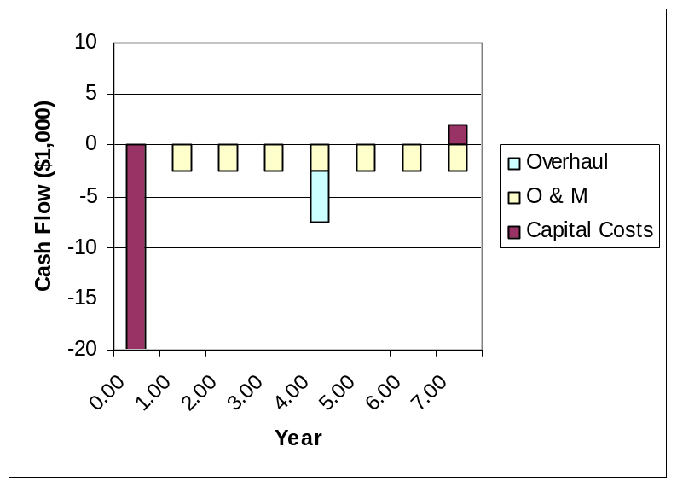

1-87

x = annual production

Let’s look at the graphical solution first, where the cost equations are:
Total Cost (A) = $20x + $100,000
Total Cost (B) = $5x + $200,000
Total Cost (C) = $7.5x + $150,000

[See graph below]

Quatro Hermanas wants to minimize costs over all ranges of x. From the graph we see that there are three breakeven points: A & B, B & C, and A & C. Only A & C and B & C are necessary to determine the minimum cost alternative over x. Mathematically the breakeven points are:

A & C: $20x + $100,000 = $7.5x + $150,000 x = 4,000
B & C: $5x + $200,000 = $8.5x + $150,000 x = 20,000

Thus our recommendation is, if:

0 ≤ x < 4,000 choose Alternative A
4,000 < x < 20,000 choose Alternative C
20,000 ≤ x 30,000 choose Alternative B

X | A | B | C
0 | 100 | 200 | 150
10 | 300 | 250 | 225
20 | 500 | 300 | 300
30 | 700 | 250 | 375
$200
$400
$600
$800
0 5 10 15 20 25 30
Production Volume (1,000 units)
A

B

C

Y_{A} = 100,000 + 20x
Y_{B} = 200,000 + 5x
Y_{C} = 150,000 + 7.5x
A Best
B Preferred
BE = 25,000
C Preferred
BE = 100,000

1-89

Each company can save on two trips.
Driver’s charges per trip = $185
Distance per trip = 300 km, as the distance one way is 150 km and we need to consider a full trip
Operating charges per km = $0.375
Operating charges per trip = $112.50
Total cost per trip = $297.50
Total savings per week = $595.00

Each company could therefore save $595.00 per week if they haul the other company’s cargo on the return trip.

1-90

We note that a lot of the information presented in the question is irrelevant, since we are only concerned with the difference between Plans (a) and (b).

Plan (a): Every year Willie gets $0.3 × 29,000 in operating expenses plus $3,500 for the decline in value of his car, for a total of $12,200

Plan (b): Every year Willie gets $0.5 × 29,000 = $14,500

Clearly Plan (b) is superior to Plan (a).

The break-even point between the two plans occurs for an annual travel distance of x km, where 0.3x + 3500 = 0.5x.

This can be solved to give x = 3500/0.2 = 17,500 km. If Willie drives more than this, he should go with Plan (b), otherwise Plan (a) is better.

1-91

If sell in December: Cost per use = (500 – 200) / 52 = $5.77.

If sell in May: Cost per use = (500 – 100) / 72 = $5.56.

The cost to move it is roughly equal to four to five uses.

The longer you keep and use the equipment, the further its cost per use will drop. If you value the exercise that you get using the exercise equipment, you should keep it—particularly since there is no convenient gym at the new location. The moving cost is only 5% of its original cost and, presumably, its replacement cost, so moving it is cheap. Sell it in December only if you absolutely need the $200 and you feel the exercise is not benefitting your health.

